**Chapter 1**

**Introduction**

In recent years, the landscape of medical diagnostics has been dramatically transformed by the integration of advanced computational models, particularly in the realm of chronic [1] and infectious diseases such as Diabetes, Alzheimer's, Skin Cancer, Lung Cancer, and Malaria [2]. Traditional diagnostic methods, which often rely heavily on invasive procedures and biochemical analysis, are increasingly being supplemented and even replaced by ML algorithms and neural network systems. These technological advancements have the potential to revolutionize how medical professionals diagnose and manage diseases, promising faster, more accurate, and less invasive diagnostics. However, despite these advancements, significant challenges remain in the accuracy, adaptability, and acceptance of these technologies within existing medical frameworks.

**1.1 Unresolved Issues and Emerging Opportunities**

The field of ML in medical diagnostics is burgeoning with potential yet is concurrently fraught with unresolved issues that impede its full-scale implementation. As technologies like CNNs and Random Forest Classifiers become more sophisticated, the medical community faces several critical challenges. Firstly, the integration of these technologies into clinical workflows is often hindered by a lack of standardization across different health systems and a dearth of training among medical professionals to effectively leverage these tools.

Secondly, issues of data privacy, security, and ethical use of medical data continue to pose significant concerns, as the increasing use of big data and AI necessitates stringent controls to protect patient information. These unresolved issues open a myriad of emerging opportunities for innovation and improvement. There is a clear demand for developing standardized protocols and training programs that can facilitate the seamless integration of AI tools into healthcare settings.

Moreover, enhancing the security architecture of AI systems to safeguard patient data presents another critical area for development. Additionally, the adaptation of ML models to be more inclusive and effective across diverse populations remains a significant opportunity, as current models often fail to account for genetic, environmental, and lifestyle variances across different demographics.

**1.1.1 Unresolved Issues:**

* **Data Heterogeneity and Integration:** Despite the proliferation of data-driven technologies, the heterogeneity of medical data poses a significant challenge. Medical datasets vary greatly in terms of structure, quality, and format, which complicates the process of integrating and standardizing data across multiple sources. This issue not only hampers the development of universal diagnostic models but also affects the accuracy and reliability of predictions made by ML algorithms [2].
* **Algorithmic Bias:** ML models are only as good as the data they are trained on, and biased data leads to biased predictions. This is particularly problematic in medical diagnostics where biased algorithms could lead to misdiagnoses or inappropriate treatment recommendations, especially for underrepresented populations in medical research datasets.
* **Regulatory and Compliance Issues:** The integration of ML into medical practice is also hindered by complex regulatory landscapes that vary by region and country. Ensuring compliance with these regulations, particularly regarding patient data privacy (such as GDPR in Europe and HIPAA in the USA), adds another layer of complexity to deploying these technologies.
* **Scalability and Adaptability:** Many ML models developed for diagnostics are not easily scalable or adaptable to different healthcare settings or diseases. This limits their practical utility and restricts their impact to specific contexts or locations, rather than benefiting a broader patient population.

**1.1.2 Emerging Opportunities:**

* **Advanced Algorithms for Enhanced Prediction:** There is a growing opportunity to develop more advanced ML algorithms that can handle the complexity and diversity of medical data more effectively. Techniques such as deep learning and transfer learning offer promising avenues for creating models that can generalize better across different populations and conditions, potentially overcoming some of the biases present in current systems.
* **Interoperable Systems:** Developing interoperable systems that can seamlessly integrate with existing healthcare IT infrastructures is a critical opportunity. Such systems would enable the easy exchange and analysis of health data, facilitating more comprehensive and accurate diagnostics and patient management.
* **Personalized Medicine:** ML holds significant promise for advancing personalized medicine, where treatments and medical interventions can be tailored to individual patients based on their unique genetic makeup and lifestyle. By leveraging ML to analyse vast arrays of personal health data, medical professionals can develop more effective, personalized treatment plans.
* **Ethical AI Frameworks:** As the use of AI in healthcare continues to expand, there is a pressing need for ethical frameworks that guide the development and implementation of these technologies. This includes ensuring that AI systems are transparent, equitable, and accountable, and that they uphold the highest standards of data privacy and patient rights.
* **Collaborative Research Initiatives:** Finally, there is an opportunity for greater collaboration between technologists, clinicians, and academics to drive innovation in the field. Multi-disciplinary research can address the practical challenges of implementing AI in clinical settings, leading to more robust, effective, and user-friendly AI solution.

**1.2 Motivation**

The drive to innovate within the field of medical diagnostics stems from the urgent need to enhance the accuracy, efficiency, and accessibility of disease detection and monitoring. This motivation is fuelled by the potential of ML and artificial intelligence to revolutionize healthcare services. These technologies promise not only to improve outcomes but also to reduce costs and increase the scalability of healthcare solutions. The continuous evolution in computational power and algorithmic sophistication allows for the tackling of complex diagnostic challenges that were previously insurmountable, creating a strong impetus for their integration into medical practice.

**1.2.1 Latest Advancements**

Recent years have seen significant advancements in the application of ML to medical diagnostics. Notably, CNNs and Random Forest classifiers have been successfully applied to detect and diagnose a variety of diseases with high accuracy. For instance, Convolution Neural Network have shown exceptional performance in medical image analysis, significantly enhancing the detection of pathologies in imaging data such as X-rays, Blood Cell Samples, MRI scans, and dermatological photographs. These advancements not only improve diagnostic accuracy but also help in predicting disease progression and response to various treatments.

**1.2.2 Lacunas/Disadvantages**

Despite these advancements, several lacunas remain. Many ML models require large amounts of high-quality data to train effectively, which is not always available, particularly in less-developed regions. Additionally, these models often lack the ability to explain their decision-making processes, leading to potential trust issues among medical professionals and patients alike. This "black box" nature of AI systems makes them difficult to audit, which is a crucial requirement in medical applications for ensuring safety and efficacy.

**1.2.3 Proposal to Overcome Lacunas**

To address these disadvantages, several proposals can be considered:

* **Data Augmentation and Synthetic Data Generation:** Implementing techniques such as data augmentation and the generation of synthetic data can help overcome the limitation of scarce data. These methods can expand the diversity and volume of training datasets, making ML models more robust and less prone to bias.
* **Development of Explainable AI (XAI)**: Advancing research into explainable AI can help demystify the decision-making processes of AI models. This is crucial for gaining the trust of healthcare providers and patients, ensuring that practitioners understand how diagnoses are derived.
* **Regulatory Frameworks and Standardization**: Establishing clear regulatory frameworks and standards for the deployment of AI in healthcare is essential. These frameworks should ensure that AI systems are safe, reliable, and capable of performing at par with or better than traditional diagnostic methods.
* **Collaborative Training Programs**: Developing training programs that bring together data scientists, AI experts, and healthcare professionals can facilitate better understanding and integration of AI technologies in clinical settings. These programs can help medical practitioners become more proficient in using AI tools, leading to more effective implementation.

**1.3 Objective and Scope of the Project**

The field of healthcare is on the cusp of a revolution, driven by the rapid advancements in artificial intelligence and ML. These technologies have the potential to drastically improve diagnostic accuracy, patient outcomes, and the overall efficiency of medical services. The primary objective of this project is to harness these cutting-edge technologies to develop a robust diagnostic tool that leverages ML algorithms for the prediction and diagnosis of various diseases. The scope of this project extends beyond merely implementing existing technologies; it aims to innovate and refine AI applications in healthcare to provide more precise, efficient, and accessible diagnostics across diverse populations.

**1.3.1 Objective**

The main objective of this project is to develop a ML-based diagnostic system that can accurately predict and diagnose diseases such as Diabetes, Alzheimer's, Skin Cancer, Lung Cancer, and Malaria [2] from diverse data inputs including clinical data and medical images. This system aims to integrate advanced algorithms like CNNs and Random Forest Classifiers with a user-friendly interface that allows easy input and interpretation of data by medical professionals. This integration is intended to facilitate quicker, more accurate medical diagnoses and tailored treatment plans, enhancing the overall quality of patient care.

**1.3.2 Scope**

The scope of this project encompasses several key areas:

* **Algorithm Development and Optimization:** Developing and fine-tuning ML algorithms that are specifically optimized for high accuracy and reliability in disease prediction and diagnosis. This involves not only the application of existing models but also potentially developing new models that can better handle the specific challenges associated with medical diagnostics.
* **Data Handling and Processing:** Establishing robust systems for the handling and processing of large datasets that include diverse types of data, such as structured clinical data and unstructured imaging data. Ensuring the privacy and security of this data is also a critical part of the project scope.
* **Integration into Clinical Workflows:** Designing the system to be easily integrable into existing clinical workflows with minimal disruption. This includes ensuring that the system is compatible with existing healthcare IT systems and that it can be easily used by medical personnel without extensive technical training.
* **Testing and Validation:** Rigorously testing the system with real-world data to validate its accuracy and reliability. This includes conducting trials in various healthcare settings to ensure that the system performs well across different environments and patient demographics.
* **Ethical Considerations and Compliance:** Addressing all ethical considerations related to the use of AI in healthcare, including patient consent and data privacy. The project also aims to comply with all relevant healthcare regulations and standards.

**1.4 Methodology:**

Methodology in scientific research refers to the systematic, theoretical analysis of the methods applied to a field of study. It comprises the theoretical underpinnings of investigation techniques, including rules, principles, and postulates employed by a discipline. In the context of our project, the methodology describes the specific processes, techniques, and tools that are utilized to develop, test, and validate the ML models designed for diagnosing diseases [3]. This encompasses the collection of data, the selection and application of ML algorithms, the evaluation of model performance, and the integration of these models into practical, user-friendly applications that can be employed in clinical settings.

Some of the methodology in our project are:

* **Data Acquisition:** The first step involves acquiring comprehensive and diverse datasets from credible sources. For our project, datasets were primarily sourced from Kaggle.com and National Institutes of Health, a platform known for its vast repository of medical datasets. These datasets include a wide range of information, from clinical data to medical images, relevant to diseases such as Diabetes, Alzheimer's, Skin Cancer, Lung Cancer, and Malaria.
* **Data Preprocessing:** Once the data is collected, it undergoes rigorous preprocessing steps. This includes data cleaning to remove any inconsistencies or errors, normalization to standardize the range of data features, and data augmentation to enhance the size and quality of our training datasets. Such preprocessing is crucial for the effective training of ML models, as it ensures that the data fed into the models is accurate and representative of real-world scenarios.
* **Model Selection and Training:** The project employs various ML algorithms based on the nature of the data and the specific disease being targeted. For instance, Random Forest classifiers are used for predictive tasks involving structured data like clinical records, while CNNs are utilized for tasks requiring image recognition, such as the detection of skin cancer lesions. These models are trained on the pre-processed data, using a split of training and validation sets to optimize their parameters.
* **Performance Evaluation:** After training, the models undergo a thorough evaluation phase where their performance is assessed based on standard metrics such as accuracy, sensitivity, specificity, and area under the curve (AUC). This step is vital to ensure that the models provide reliable and valid results when deployed in a real-world medical setting.
* **Deployment and Integration:** The final step involves deploying the trained models into a web-based application, designed to be user-friendly and easily accessible by medical professionals. The application uses Flask, a Python web framework, to create a lightweight, efficient backend that supports real-time disease prediction. This system is integrated into existing clinical workflows, allowing for seamless access and use by healthcare providers.
* **Feedback and Iterative Improvement:** Post-deployment, continuous feedback is collected from end-users to identify any areas of improvement. This feedback is used to make iterative adjustments to the models and the application, ensuring the system remains relevant and effective as new data becomes available and as user needs evolve.

**1.5 Organization of the Report**

The organization of a dissertation or a report outlines the structural framework that governs the presentation of research. It is crucial as it guides the reader through the logical flow of the research’s purpose, methods, results, and conclusions. This structured presentation helps to clearly articulate the research question, methodologies employed, findings, and the implications of those findings. In essence, the organization of the dissertation is the roadmap that details each part of the research study from the introduction to the appendices, ensuring that the information is coherent, sequential, and easy to follow.

The dissertation for this project on the application of ML in medical diagnostics [3] is organized into several key sections, each designed to provide a comprehensive insight into the various aspects of the research:

* **Introduction:** This initial chapter sets the stage for the research by providing background information on the use of ML in healthcare. It discusses the current landscape, the potential of ML technologies, and the specific needs that the project aims to address. This section also outlines the motivation, objectives, and scope of the research.
* **Literature Review:** Following the introduction, the literature review details the existing research and developments in the field. It critically analyses previous studies, discusses major findings, and highlights the gaps that the current project intends to fill. This review supports the research rationale and helps in positioning the project within the broader field of study.
* **Methodology:** This section describes the detailed methods used in the project, from data collection and preprocessing to model training and validation. It explains the choice of algorithms, the design of experiments, the statistical tools used for analysis, and the criteria for evaluating the results.
* **Results and Discussion:** Here, the outcomes of the empirical research are presented and discussed. This part not only reports the findings from the ML models but also interprets these results in the context of the research questions and hypotheses. It discusses the implications of the findings, comparing them with existing literature and considering their practical applications.
* **Conclusion and Recommendations:** The dissertation concludes with a summary of the findings and the conclusions drawn from the research. It also offers recommendations based on the research outcomes, suggesting future research directions and potential improvements in the application of ML in medical diagnostics.
* **References:** This essential section lists all the bibliographic references used throughout the dissertation, formatted according to the specified academic standards.
* **Appendices:** Finally, supplementary material that is too detailed to include in the main body of the dissertation, such as data tables, additional figures, and technical documentation, is provided in the appendices.

**1.6 Software Requirements**

Software requirements define the specifications that software must fulfil to meet the needs of its users and to achieve the objectives of its deployment. These requirements detail the functional and non-functional expectations of the software system, ensuring compatibility, usability, and performance standards are met. In the context of a project, specifying software requirements is crucial as it guides the development process, informing developers of the necessary hardware compatibility, operating systems, APIs, and other tools needed for the software to function correctly and integrate seamlessly into existing systems.

For the successful implementation of our ML-based diagnostic system, several software requirements must be met to ensure optimal functionality and user experience. These requirements are categorized as follows:

* **Platform:** The system is designed to be platform-independent to ensure wide accessibility and functionality across different operating systems. However, for development and testing purposes, the primary platforms used are Windows 10 and Linux. These platforms support the various development tools and libraries required for ML model development and deployment.
* **APIs and Drivers:** The project utilizes various APIs and drivers to handle data processing and ML tasks efficiently. TensorFlow and Keras APIs are integral for developing and training the ML models. Additionally, specific drivers are required to ensure that the underlying hardware, particularly GPUs, are fully utilized for computational tasks, enhancing the performance of deep learning models.
* **Web Browser Compatibility:** The web-based interface of the diagnostic system is designed to be compatible with modern web browsers, including Google Chrome and Microsoft Edge. This compatibility ensures that users can access the system from any device without functionality issues, providing flexibility and ease of use in clinical settings.
* **Software Tools:** The development environment for the project is primarily based on Visual Studio Code. VS Code provides a versatile and powerful editor that supports multiple programming languages such as Python, which is used for scripting the ML models. It also offers useful extensions for managing software containers, version control, and integrating APIs, making it an ideal choice for developing complex software projects like this one.
* **Additional Software Requirements:** The project also requires the installation of Python 3.8 or later, along with pip for managing additional Python packages. Key libraries such as NumPy, Pandas, Matplotlib, Scikit-learn, and others are essential for data manipulation, statistical analysis, and visualization. These libraries are critical for the preprocessing of data and evaluation of the ML models.

**1.7 Hardware Requirements**

Hardware requirements refer to the specifications of the physical components necessary for software to operate efficiently and effectively. These specifications ensure that the system has adequate resources to perform its intended functions without lag or disruption, particularly important in systems that handle complex tasks such as data processing and ML. Defining hardware requirements is essential for the smooth deployment of software, as it guarantees compatibility between the software and the hardware, optimizing performance and preventing system overloads.

The successful deployment and operation of our ML-based diagnostic system depend on specific hardware configurations that can support intensive computational tasks associated with processing and analysing large datasets. The following are the key hardware requirements:

* **Architecture:** The system is optimized for 64-bit architecture, which supports extensive computational tasks and large amounts of memory. This architecture is essential for handling the complex algorithms and large data sets typical of ML operations.
* **Processing Power:** A multi-core processor (Intel i3 or AMD Ryzen 3 equivalent or better) is required to manage the intense computational demands of training ML models. High processing power ensures that the system can perform multiple tasks simultaneously without performance degradation, crucial for real-time data processing and analysis.
* **Memory:** At least 6GB of RAM is recommended to efficiently handle the operations of the system. Adequate memory is crucial for speeding up the processes of data loading, model training, and model execution, especially when dealing with large datasets or deep learning models.
* **Secondary Storage:** A minimum of 128GB of solid-state drive storage is required to store the large datasets, software, and the operating system. SSDs are preferred due to their faster data access speeds compared to traditional hard drives, which can significantly improve the performance of data-intensive applications.
* **Display Adapter:** A dedicated graphics card, such as an NVIDIA GTX 1080 or equivalent, is recommended, particularly for tasks that involve image processing and data visualization. A powerful GPU is also beneficial for accelerating the training of deep learning models that are part of the diagnostic system.
* **Peripherals:** Standard peripherals including a keyboard, mouse, webcam, and a monitor with at least 1080p resolution are required for interacting with the system. In clinical settings, high-resolution monitors may be necessary to accurately view medical images.

**Chapter 2**

**Literature Survey**

This literature survey aims to explore the recent advancements and research findings related to the application of ML across five major diseases: Diabetes, Alzheimer's, Skin Cancer, Lung Cancer, and Malaria. The focus of this first section is on Diabetes, a prevalent chronic disease where ML has had a considerable impact on improving outcomes.

The integration of ML in medical diagnostics has emerged as a transformative force in healthcare, offering new avenues for enhancing disease detection, diagnosis, and management. ML models, particularly deep learning techniques, have shown significant potential in interpreting complex medical data, leading to more accurate and timely diagnoses. As highlighted by I. Mohit, K. S. Kumar, U. A. K. Reddy, and B. S. Kumar [3], the use of ML and deep learning in multiple disease prediction demonstrates the extensive capability of these technologies to address diverse medical conditions effectively. Additionally, they have underscored the versatility of ML algorithms in detecting various diseases, showcasing their broad applicability and innovative potential in healthcare. The use of these technologies spans various diseases, each presenting unique challenges and opportunities for innovation.

**2.1 Introduction to Diabetes Diagnosis**

Diabetes, characterized by its chronic nature and significant impact on quality of life, has been the focus of numerous studies aiming to leverage ML for better disease management and prediction. ML models have been particularly useful in predicting the onset of diabetes and managing its complications, thereby aiding in preventative healthcare measures and treatment adjustments.

* **Predictive Modelling:** A study by D. Kumar, R. Verma, and A. Singh [4], utilized multiple ML algorithms to predict changes in fasting blood glucose and glycated haemoglobin in patients with type 2 diabetes. Their research demonstrated that ML models could effectively forecast glycaemic control outcomes, which are crucial for preventing the progression of diabetes-related complications [5].
* **Risk Factor Analysis:** ML algorithms are also employed to analyse various risk factors and their contributions to diabetes. By processing large datasets, ML models can identify patterns and risk factors that are not apparent through traditional statistical methods.
* **Treatment Personalization:** The application of ML in diabetes extends to personalizing treatment regimes. By analysing individual patient data, ML models can recommend the most effective treatment plans that are tailored to individual patient profiles, potentially increasing the success rates of managing the disease.
* **Remote Monitoring and Wearable Technologies:** The advent of wearable health technologies has facilitated the remote monitoring of diabetic patients, generating data that ML models can analyse to provide real-time feedback and early warnings regarding potential health issues.
* **Automated Retinal Screening:** ML models, especially deep learning networks, have proven effective in automated screening for diabetic retinopathy, a common complication of diabetes [6]. These models analyse retinal images to detect early signs of retinopathy, allowing for timely intervention and treatment.
* **Lifestyle Management:** Another critical application of ML in diabetes care is in lifestyle management, where predictive models help tailor dietary and exercise recommendations based on the patient's daily glucose readings and other health data [7]. This personalized approach helps in better glycaemic control, crucial for long-term management of diabetes.

**2.2 Introduction to Alzheimer’s Diagnosis**

Alzheimer's disease, a progressive neurodegenerative disorder, poses significant diagnostic challenges due to its gradual onset and the complexity of its symptoms. Recent advancements in ML have shown promising potential in early detection and monitoring of Alzheimer's, utilizing various biomarkers and imaging techniques.

Literature Survey on Alzheimer’s Diagnosis [8] through ML

* **Early Detection:** Studies have demonstrated that ML models can detect the early stages of Alzheimer’s by analysing patterns in patient data that are typically imperceptible to humans. For instance, CNNs are employed to analyse MRI to identify subtle changes in brain structure and function that precede the onset of symptoms [9].
* **Cognitive Decline Prediction:** ML algorithms analyse historical and real-time cognitive performance data to predict the progression rate of Alzheimer’s. This predictive capacity is crucial for planning treatment and care, potentially slowing the progression and improving the quality of life for patients.
* **Integrating Multimodal Data:** The complexity of Alzheimer's disease requires the integration of multimodal data sources, including genetic, biochemical, and lifestyle information, to improve the accuracy of diagnosis and predictions. ML’s ability to handle large, diverse datasets makes it an ideal tool for this integrative approach.
* **Enhancing Diagnostic Accuracy:** ML is particularly beneficial in enhancing the diagnostic accuracy for Alzheimer's disease by combining clinical assessments with algorithmic analysis. By correlating patient symptoms with known disease markers analysed by AI, clinicians can make more informed decisions regarding the diagnosis and differentiation of Alzheimer's from other types of dementia [10].
* **Patient Monitoring and Care Optimization:** ML models are also being used to monitor the health status of Alzheimer’s patients continuously, which helps in adjusting treatments in real-time based on the patient's current needs. This dynamic approach to patient care helps in managing the day-to-day challenges of Alzheimer's care, significantly enhancing patient and caregiver experiences.

**2.3 Introduction to Skin Cancer Diagnosis**

Skin cancer, one of the most common forms of cancer globally, requires accurate and early diagnosis to ensure effective treatment. ML has revolutionized the field of dermatology by enabling the precise analysis of skin lesion images, significantly improving the detection and diagnosis of various skin cancers.

Literature Survey on Skin Cancer Diagnosis [11] through ML

* **Automated Image Analysis:** Deep learning, a subset of ML, has been extensively applied to the analysis of Dermatoscopy images. CNNs, for instance, have demonstrated high accuracy in differentiating between benign and malignant skin lesions. These models are trained on vast datasets of labelled images, allowing them to learn and predict with high precision [12].
* **Skin Disease Detection:** Specifically, in the detection of skin diseases, ML models have outperformed traditional diagnostic methods. These models are capable of identifying not only melanoma, the deadliest form of skin cancer, but also seven other types of skin diseases Actinic keratosis, Basal cell carcinoma, Benign keratosis-like lesions, Dermatofibroma, Melanocytic nevi, and Vascular lesions [13]. By analysing subtle patterns in skin images that are typically difficult for the human eye to detect, these models provide a valuable tool for dermatologists. This comprehensive approach enhances the accuracy of diagnoses and aids in the early detection and treatment of various skin conditions.
* **Integration on Web Application:** The integration of ML algorithms with Web technology has led to the development of applications that allow users to capture images of their skin lesions and receive immediate preliminary assessments. This application significantly enhances accessibility to preliminary diagnostics, encouraging early doctor consultations.
* **Enhanced Precision in Diagnosis:** ML not only aids in the early detection of skin cancer but also enhances the precision of diagnoses [14]. Advanced algorithms analyse a broader range of data points than a human can manage, reducing the rate of false positives and negatives, and improving the reliability of skin cancer screenings.
* **Training and Learning Capabilities:** One significant advantage of ML models is their ability to continually learn and improve. As these models are exposed to more Dermatoscopy images and patient data, their diagnostic accuracy and speed improve, thereby enhancing their utility in clinical settings.

**2.4 Introduction to Lung Cancer Diagnosis**

Lung cancer, characterized by its high mortality rate, benefits significantly from early detection, which can greatly improve treatment outcomes. ML models are increasingly being used to analyse complex imaging data, such as chest X-rays and CT scans, to detect early-stage lung cancer with high accuracy.

Literature Survey on Lung Cancer Diagnosis [15] through ML

* **Image Analysis for Early Detection and Post Detection of Disease:** ML algorithms, particularly CNNs, have shown remarkable ability in identifying lung cancer [16] signatures in imaging data. These models can detect minute anomalies in lung tissues that might be indicative of early-stage cancer, which are often missed during traditional manual examinations.
* **Predictive Models for Treatment Outcomes:** Beyond detection, ML models are employed to predict the outcomes of various treatment options. By analysing patient data and previous treatment results, these models can forecast the efficacy of specific treatments for individual patients, assisting oncologists in making informed treatment decisions.
* **Integration with Clinical Decision Systems:** ML is also integrated into clinical decision support systems for lung cancer [17], providing oncologists with real-time, data-driven insights. This integration helps in personalizing patient management plans, optimizing treatment protocols based on individual patient profiles.
* **Research and Clinical Trials:** AI and ML are pivotal in analysing data from clinical trials, identifying potential correlations and outcomes that can lead to more effective treatment strategies for lung cancer. This data-driven approach accelerates the research process, enabling faster introduction of effective treatments to the market.
* **Automated Segmentation Techniques:** ML algorithms, especially deep learning, are increasingly being used for automated segmentation of lung tumours in CT scans. These advanced techniques can accurately delineate the boundaries of lung tumours, which is crucial for assessing tumour size and growth over time, informing both diagnosis and treatment strategies.
* **Enhanced Screening Programs:** AI-powered tools are being integrated into lung cancer screening programs to assist radiologists in identifying potential lung cancer cases more efficiently [18]. This not only speeds up the screening process but also increases its accuracy, potentially saving more lives through early detection.

**2.5 Introduction to Malaria Diagnosis**

Malaria diagnosis presents unique challenges due to the need for rapid and accurate identification of the malaria parasite in blood samples. ML has emerged as a powerful tool in the fight against malaria, enhancing the capabilities of microscopic diagnosis and providing scalable solutions for endemic regions.

Literature Survey on Malaria Diagnosis [19] through ML

* **Automated Microscopic Analysis:** ML models, particularly CNNs, are revolutionizing the way microscopic images of blood smears are analysed for malaria diagnosis. These models can detect and classify the presence of malaria parasites more quickly and accurately than traditional manual microscopy [20].
* **Rapid Field Testing:** ML algorithms are being deployed in portable diagnostic devices that can be used in the field to deliver immediate results. This is particularly beneficial in rural or remote areas where access to laboratories and specialized medical personnel is limited.
* **Predictive Models for Outbreaks:** Beyond individual diagnosis, ML is also used to predict malaria outbreaks by analysing environmental and epidemiological data. These models help in forecasting regions and times of high malaria transmission, allowing for better resource allocation and targeted intervention strategies.
* **Integration with Mobile Health Applications:** ML models are integrated into mobile health applications, enabling health workers in remote areas to upload images of blood samples and receive instant diagnostic feedback. This application significantly enhances the reach and effectiveness of malaria control programs.
* **Enhancing Diagnostic Accuracy:** Leveraging ML in malaria diagnosis has significantly enhanced the accuracy over traditional methods, reducing false positives and negatives. This increase in diagnostic accuracy is crucial for ensuring appropriate treatment and reducing the unnecessary use of antimalarial drugs, which can help prevent drug resistance.
* **Training and Educational Tools:** ML models are also used as training tools for healthcare workers, especially in malaria-endemic regions [21]. These models help in educating and training medical staff by providing them with real-time feedback and guidance on identifying malaria parasites in blood smears, thus improving their diagnostic skills.

**2.6 Assessing the Influence of ML on Diverse Medical Diagnoses**

The application of ML technologies in medical diagnostics has shown profound impacts across a spectrum of diseases, offering advancements that promise to revolutionize healthcare delivery and patient management:

* **General Improvements in Diagnostic Processes:** Across all diseases discussed Diabetes, Alzheimer’s, Skin Cancer, Lung Cancer, and Malaria ML has contributed to more accurate, faster, and more cost-effective diagnostics. These improvements are pivotal in early disease detection, which is often linked to better patient outcomes and reduced healthcare costs.
* **Personalized Medicine:** ML facilitates the move towards personalized medicine by allowing for more precise disease risk assessment, early diagnosis, and tailored treatment plans based on individual patient data. This approach is particularly beneficial in managing chronic diseases and cancers, where treatment responses can vary widely among patients.
* **Global Health Impact:** In terms of global health, ML models have a significant impact on controlling infectious diseases like Malaria and improving cancer care in low-resource settings. These technologies provide scalable solutions that can be deployed in diverse environments, bridging the gap in healthcare access and quality.
* **Future Trends and Innovations:** The future of ML in healthcare looks promising, with ongoing research focusing on integrating more complex algorithms, improving data handling capacities, and enhancing the interpretability and transparency of AI models. The integration of AI with other technologies like genomics and biotechnology is also expected to yield new insights and breakthroughs in disease treatment and prevention.

**Chapter 3**

**Theory and Fundamentals**

ML is a subset of artificial intelligence that focuses on the development of systems that can learn from and make decisions based on data. In the context of medical diagnostics, ML techniques harness vast amounts of healthcare data ranging from electronic health records to medical imaging to improve the accuracy, efficiency, and effectiveness of disease detection and diagnosis. This ability to analyse complex datasets beyond human capabilities has transformed medical diagnostics, making it possible to identify subtle patterns and predictors of health outcomes that are not evident through conventional analysis methods. This section explores the fundamental theories and methodologies behind ML applications in medical diagnostics, emphasizing how these technologies are employed to tackle various diseases.

**3.1 Introduction to the Theory and Fundamentals Medical Diagnostics**

ML is a subset of artificial intelligence that focuses on the development of systems that can learn from and make decisions based on data. In the context of medical diagnostics, ML techniques harness vast amounts of healthcare data ranging from electronic health records to medical imaging to improve the accuracy, efficiency, and effectiveness of disease detection and diagnosis [22]. This ability to analyse complex datasets beyond human capabilities has transformed medical diagnostics, making it possible to identify subtle patterns and predictors of health outcomes that are not evident through conventional analysis methods. This section explores the fundamental theories and methodologies behind ML applications in medical diagnostics, emphasizing how these technologies are employed to tackle various diseases.

**3.1.1 Fundamentals**

ML models are typically classified into three main categories based on their learning approach: supervised learning, unsupervised learning, and reinforcement learning. Each type plays a critical role in medical applications:

* **Supervised Learning**: This is the most prevalent form of ML in medical diagnostics [22]. It involves training a model on a labelled dataset, where the input data (e.g., medical images, patient demographics) are paired with the correct output (e.g., disease diagnosis). The goal is for the model to learn to predict the output from the input data. Techniques such as regression analysis for predicting continuous outcomes and classification for categorical outcomes are widely used. For instance, CNNs, a type of deep learning model, are extensively used for image recognition tasks such as identifying tumor in radiology scans.
* **Unsupervised Learning:** In unsupervised learning, the model works on unlabelled data. It tries to find the underlying patterns or groupings in the data, which is useful in medical diagnostics for identifying novel or unknown patterns in disease symptoms or genetic information [22]. Clustering and dimensionality reduction are common techniques here, helping to discover structure in complex medical data, such as genetic markers associated with diseases.
* **Reinforcement Learning:** Though less common in diagnostics, reinforcement learning is used in personalized medicine and treatment planning, where an agent learns to make decisions by receiving feedback in terms of rewards or punishments. It is promising for optimizing treatment protocols over time based on patient response [22].

**3.2 The Role of Data in ML**

Data is the cornerstone of all ML applications. In the medical field, the quality, quantity, and variety of data directly impact the performance of ML models. Data preprocessing, which includes data cleaning, normalization, transformation, and augmentation, is a critical step to prepare raw data for effective ML. Ensuring data integrity and reducing biases are paramount concerns, as the decisions made by ML models can significantly affect patient outcomes.

The effective application of ML models in medical diagnostics varies by the type of disease and the data available. This section will explore some of the key models used in the diagnosis of specific diseases such as Diabetes and Alzheimer’s.

**3.2.1 Models for Diabetes Diagnosis**

**Random Forest Classifier:** This ensemble learning method is used for classifying types of diabetes and predicting patient outcomes. It operates by constructing multiple decision trees during training time and outputting the class that is the mode of the classes (classification) of the individual trees [23]. It is particularly valued for its ability to handle large datasets with numerous variables without overfitting, making it suitable for complex datasets often found in diabetic patient records.

**3.2.2 Models for Alzheimer’s Diagnosis**

**Convolutional Neural Networks:** These are deep neural networks that have shown significant success in image-based analysis, making them ideal for analysing neuroimaging data such as MRI scans to detect Alzheimer’s disease. CNNs automatically detect important features without any human supervision [23], from which they learn to identify patterns indicative of Alzheimer's progression.

**3.2.3 Model for Skin Cancer Diagnosis**

Skin Cancer, one of the most common types of cancer worldwide, can benefit tremendously from early detection, where ML offers significant advances:

* **Convolution Neural Networks:** Among the various ML models, CNNs [23] have become particularly prominent for their ability to accurately analyse and classify skin lesion images. These models are trained on thousands of images to distinguish benign moles from malignant melanomas with a degree of accuracy comparable to that of experienced dermatologists.

**3.2.4 Model for Lung Cancer Diagnosis**

Lung Cancer remains one of the deadliest cancers due to its typically late detection. ML is poised to transform this landscape through improved diagnostic accuracy and early detection:

* **EfficientNet-B0:** EfficientNet-B0 is employed for lung cancer detection due to its balance of accuracy and computational efficiency. This deep learning model analyses CT scan images to identify malignant nodules with high precision. EfficientNet-B0's architecture [24] allows it to capture intricate patterns in the lung tissues, improving early detection rates. By leveraging transfer learning and extensive data augmentation, the model enhances diagnostic accuracy, making it a valuable tool for oncologists. This approach supports timely intervention and personalized treatment plans, ultimately contributing to better patient outcomes in lung cancer care.

**3.2.5 Model for Malaria Diagnosis**

Malaria diagnosis using traditional microscopy is labour-intensive and requires substantial expertise. ML offers innovative approaches to enhance detection accuracy and speed, crucial for effective disease management in endemic areas:

* **EfficientNet-B0:** EfficientNet-B0 is employed for malaria detection due to its balance of accuracy and computational efficiency. This deep learning model analyses blood smear images to identify malaria parasites with high precision. EfficientNet-B0's architecture [24] allows it to capture intricate patterns in the blood cells, improving early detection rates. By leveraging transfer learning and extensive data augmentation, the model enhances diagnostic accuracy, making it a valuable tool for healthcare providers. This approach supports timely intervention and personalized treatment plans, ultimately contributing to better patient outcomes in malaria care [24].

**3.2.6 Integration Challenges and Future Directions**

While the potential of ML in enhancing diagnostic accuracy for diseases like Skin and Lung Cancer is immense, several challenges remain:

* **Data Quality and Availability:** High-quality, annotated medical imaging data are crucial for training effective ML models. The availability of such data, especially for rarer forms of cancer, can sometimes be limited, impacting the training and performance of the models.
* **Interdisciplinary Collaboration:** Effective deployment of ML solutions in clinical settings often requires close collaboration between AI researchers, software developers, and medical professionals. Bridging the gap between these disciplines is essential for developing practical, user-friendly systems that can be integrated into existing healthcare workflows.
* **Ethical and Regulatory Considerations:** As ML applications become more widespread in medical diagnostics, addressing ethical concerns related to patient privacy, data security, and the explainability of AI decisions becomes increasingly important.

**3.3 Summarizing the Impact of ML Across Various Medical Diagnoses**

The application of ML across various medical diagnostics has demonstrated significant benefits, reshaping the landscape of disease detection and management [24]:

* **Enhanced Diagnostic Accuracy:** Across all discussed diseases Diabetes, Alzheimer’s, Skin Cancer, Lung Cancer, and Malaria ML has consistently improved diagnostic accuracy. This improvement is crucial for early detection, which is often associated with better treatment outcomes.
* **Efficiency and Scalability:** ML models, once trained, can analyse vast amounts of data much more quickly than human experts. This scalability is vital in settings where rapid diagnosis is critical, such as in epidemic outbreaks or in high-volume urban clinics.
* **Reduction in Diagnostic Costs:** By automating parts of the diagnostic process, ML [24] can help reduce the cost of healthcare delivery. This is particularly important in low-resource settings where financial constraints may limit access to quality healthcare.

**Chapter 4**

**Design Specification**

The system architecture presented integrates various technologies and platforms to streamline the process of image-based medical diagnostics through ML. The system comprises several key components: the Pre-Trained Model, the I/O Interface, and the central Model for processing. Data begins its journey at the Pre-Trained Model, where ML models, sourced and possibly pre-trained from Kaggle.com, are fine-tuned with specific data that undergoes rigorous preprocessing to adapt to our diagnostic needs. This training process is crucial for enhancing model accuracy before deployment.

For real-time applications, the I/O Interface facilitates interaction with the system via a Flask-based user interface, which manages both input and output operations. Users can submit images through the Flask, which are then processed by the model for recognition tasks. The core Model segment employs TensorFlow-Keras for sophisticated image processing tasks and OpenCV for tasks like OCR text recognition, ensuring detailed analysis and extraction of pertinent features from medical images. The system is designed to handle inputs primarily as images, process these images using advanced algorithms, and deliver diagnostic outputs directly through the Flask UI, thereby providing an efficient and user-friendly experience for medical professionals.

**4.1 System Architecture**

The multi-model disease prediction system has been meticulously evaluated to ensure its accuracy and reliability across various medical conditions. Fig 4.1 illustrates the system architecture of the medical diagnosis platform. The architecture integrates several key components, including a pre-trained model sourced from Kaggle.com, data preprocessing stages, and the training of specific disease models. The system employs a Flask-based user interface (UI) for input and output operations, facilitating seamless image recognition and diagnostic processes.

The core processing unit leverages TensorFlow-Keras for running deep learning models, OpenCV for image processing and OCR text recognition, ensuring comprehensive analysis and accurate predictions. This robust setup supports efficient diagnostic workflows, providing high accuracy rates across the different disease models. The following sections provide a detailed analysis of the performance of each model, showcasing their strengths and the significant improvements they bring to medical diagnostics.

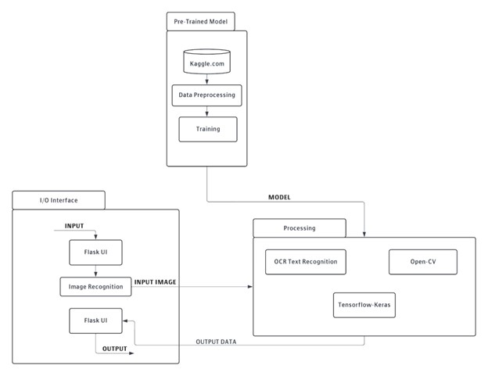

**Fig 4.1:** System Architecture of Medical Diagnosis

* **Pre-Trained Model**
* **Kaggle:** This element represents the source of the pre-trained models and potentially the datasets used for training these models. Kaggle is a platform that provides a vast array of datasets and ML models, which can be utilized to train models specific to your needs, such as disease prediction.
* **Data Preprocessing:** Before being used for training, the data from Kaggle undergoes preprocessing. This step typically involves cleaning the data, normalizing it, augmenting it (if necessary), and transforming it into a format suitable for training ML models.
* **Training:** This block represents the process where the pre-processed data is used to train or fine-tune the pre-trained models. The training process adjusts the weights and parameters of the models so they are better suited to perform the specific task of disease prediction based on medical images.
* **I/O Interface**
* **Input/Output via Flask:** This portion of the diagram indicates that the system uses Flask, a Python web framework, to create a user interface (UI). This UI handles input and output operations:
* **Input:** Users upload images through the Flask. These images are presumably medical images related to diseases.
* **Image Recognition:** Once an image is uploaded, it is processed by image recognition technologies that likely use aspects of the pre-trained models and it will call a dedicated disease model, then it will process that image.
* **Output:** After processing the image and making a prediction, the output (the prediction results) is displayed to the user through the Flask.
* **Model**
* **Processing:** This is a general block that likely involves various ML or data processing steps necessary to interpret the input image and extract relevant features from it.
* **OCR Text Recognition:** For images that contain textual information (like scans of medical reports), the system uses Optical Character Recognition (OCR) technology to convert text within images into machine-encoded text. This process utilizes OpenCV, a library focused on real-time computer vision.
* **TensorFlow-Keras:** These are the main tools used for building and running the ML models. TensorFlow provides a comprehensive, flexible ecosystem of tools, libraries, and community resources that lets researchers push the state-of-the-art in ML, and developers easily build and deploy ML-powered applications. Keras is a high-level neural networks API, written in Python and capable of running on top of TensorFlow, which makes it more user-friendly for developing deep learning models.

**4.2 Model Workflow**

The multi-model disease prediction system has been meticulously evaluated to ensure its accuracy and reliability across various medical conditions. Fig 4.2 illustrates the model workflow of the disease diagnosis platform. The workflow begins with the collection of data from Kaggle.com, which provides comprehensive datasets for model training. The data undergoes preprocessing to clean and normalize it, ensuring it is suitable for training.

The system employs different ML models tailored to each disease: EfficientNet-B0 for lung cancer detection, a Random Forest Classifier for diabetes prediction, customized CNN and EfficientNet-B0 for skin and malaria detection, and ResNet-50 for Alzheimer's diagnosis. This structured approach ensures that each model is optimized for its specific task, enhancing the overall accuracy and effectiveness of the system. The following sections provide a detailed analysis of the performance of each model, showcasing their strengths and the significant improvements they bring to medical diagnostics

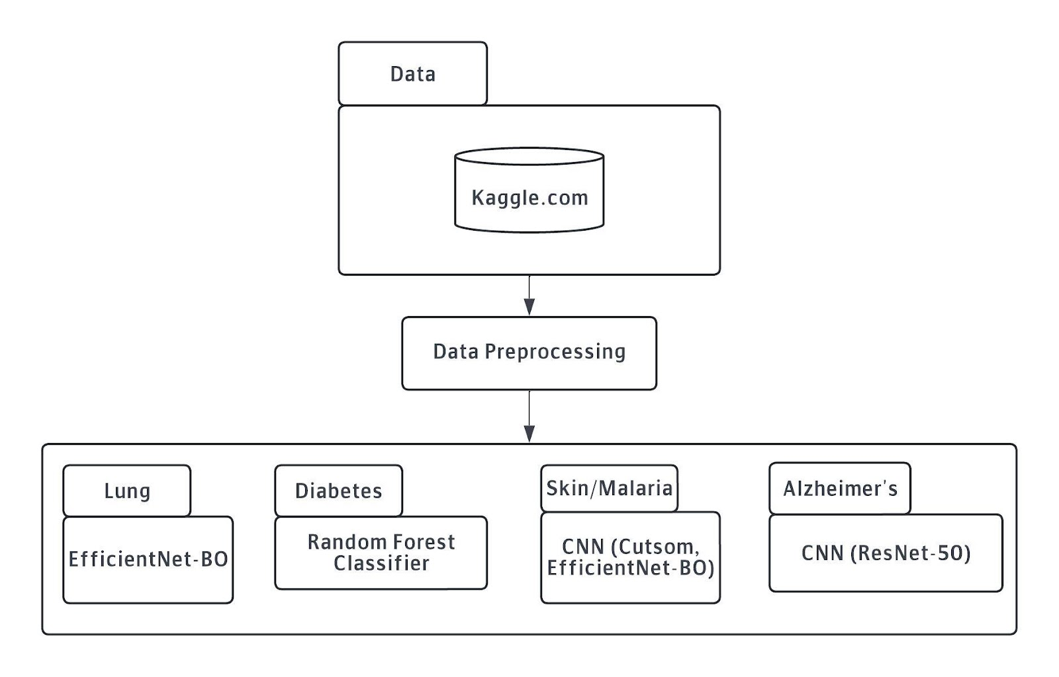

**Fig 4.2:** Model Workflow of Disease Diagnosis

**Components and Workflow**

* **Data Source and Preprocessing**
* **Kaggle:** The primary data source for training the ML models. Kaggle provides diverse datasets, including medical images and clinical data, necessary for training robust prediction models.
* **Data Preprocessing:** Involves cleaning, normalizing, and augmenting the data to ensure it is suitable for training. This step is critical for enhancing the quality and performance of the ML models.
* **Model Training**
* **Pre-Trained Model:** The system uses pre-trained models which are fine-tuned using the pre-processed data from Kaggle. These models are specifically tailored for each disease type, leveraging different ML algorithms optimized for their respective tasks.
* **Disease-Specific Models**
* **Diabetes:** Utilizes the Random Forest Classifier, which is effective for tabular clinical data analysis. This model predicts diabetes by analysing features such as blood glucose levels, BMI, age, HBA1C factors.
* **Alzheimer’s:** Employs CNNs like ResNet-50. These models are trained on MRI scans to identify patterns indicative of Alzheimer's disease.
* **Malaria:** Uses CNN models such as EfficientNet-B0, which are trained on blood smear images to detect malaria parasites.
* **Skin Cancer:** It uses Custom CNN models, which analyse Dermatoscopy images to distinguish between benign and malignant skin lesions.
* **Lung Cancer:** Utilizes a EfficientNet-B0 CNN model designed for segmenting and analysing lung CT scans. This model identifies nodules and other lung abnormalities indicative of cancer.
* **Input/Output Interface**
* **Flask:** A web interface built using Flask, which handles user interactions. Users upload their medical images through this interface.
* **Image Recognition:** The system processes the uploaded images using the appropriate disease model based on the classification of the image type.
* **Result Display:** The Flask also displays the prediction results, providing users with diagnostic information about the uploaded image.

**4.3 Flow Chart**

The multi-model disease prediction system has been meticulously evaluated to ensure its accuracy and reliability across various medical conditions. Fig 4.3 illustrates the flow chart of the disease diagnosis process. The workflow starts with the user uploading an image via the website interface. Upon receiving the image, the system classifies it to determine the type of disease model required, such as those for Diabetes, Alzheimer's, Malaria, Skin Cancer, or Lung Cancer. If the image type is identified, the appropriate disease model is selected to predict the disease. If the image type is unknown, the system handles it as an unidentified image. The prediction results are then displayed on the website, providing the user with diagnostic information. This structured approach ensures a seamless and efficient diagnostic process, enhancing the system’s usability and accuracy. The following sections provide a detailed analysis of the performance of each model, showcasing their strengths and the significant improvements they bring to medical diagnostics.

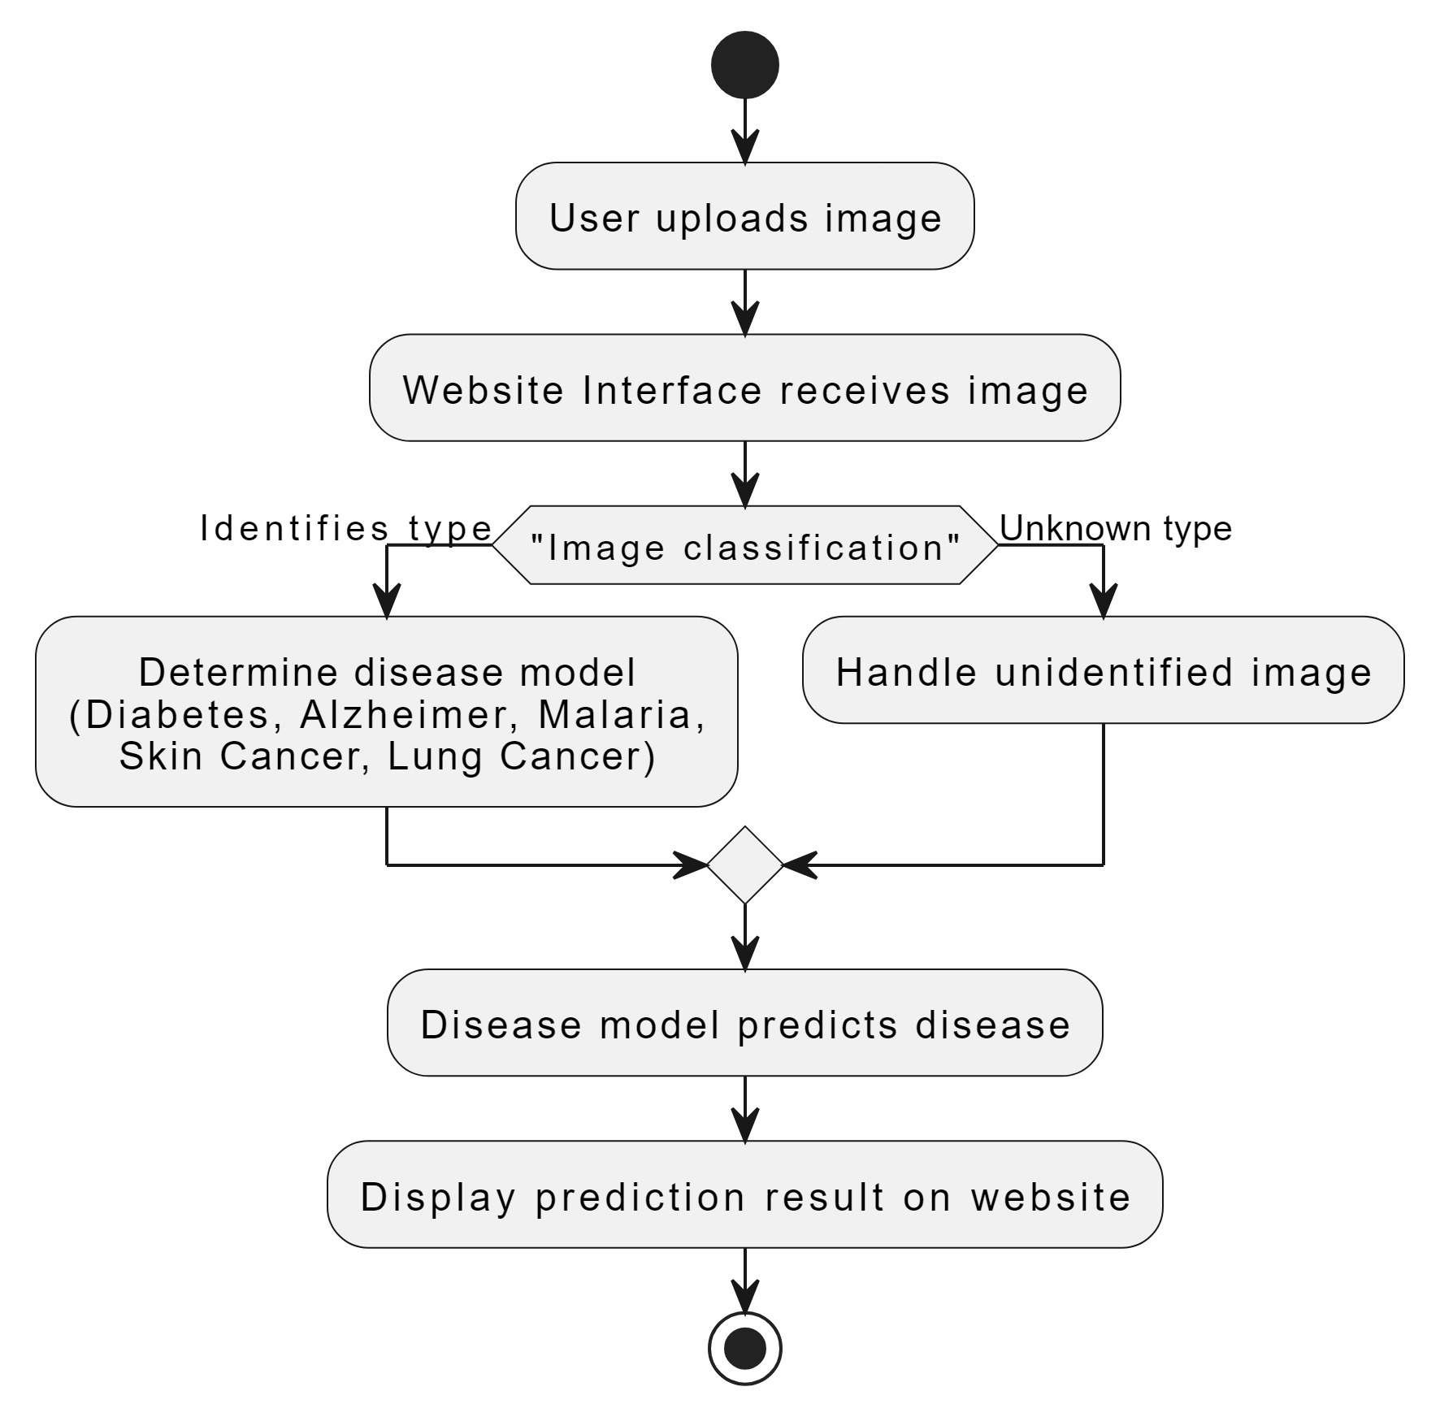

**Fig 4.3:** Flow Chart of Disease Diagnosis

* **User:** This actor initiates the process by uploading an image to the system via the website interface.
* **Website Interface:** Receives the image from the user.
* **Image Classification System:** Classifies the image to determine which type of disease it may indicate. This step decides which specific disease model to invoke.
* **Disease Prediction Model:** Based on the image classification, the relevant disease models and analyses the image to predict the presence and type of disease.
* **Result Display:** Once the disease is predicted by the model, the result is sent back to the user interface, which displays the outcome to the user.

**4.4 Use-Case Diagram**

The multi-model disease prediction system has been meticulously evaluated to ensure its accuracy and reliability across various medical conditions. Fig 4.4 illustrates the use case diagram of the disease diagnosis process. The workflow begins when the user uploads an image through the website interface. The system then triggers the classification of the image to identify the type of disease. Once the image type is determined, the appropriate disease model-such as those for Diabetes, Alzheimer's, Malaria, Skin Cancer, or Lung Cancer-is invoked to analyse the image and predict the disease.

The results are sent back to the website interface, where they are displayed to the user. This comprehensive approach ensures a streamlined and efficient diagnostic process, providing users with accurate and timely predictions. The following sections provide a detailed analysis of the performance of each model, showcasing their strengths and the significant improvements they bring to medical diagnostics.

* **Actors**
  + **User:** The primary actor who interacts with the system by uploading images.
* **Main Website Functionalities (Use Cases within the Website rectangle)**
  + **Input Image:** The user uploads an image to the system.
  + **Classify Image:** The system processes the uploaded image to classify it based on features that pertain to specific diseases.

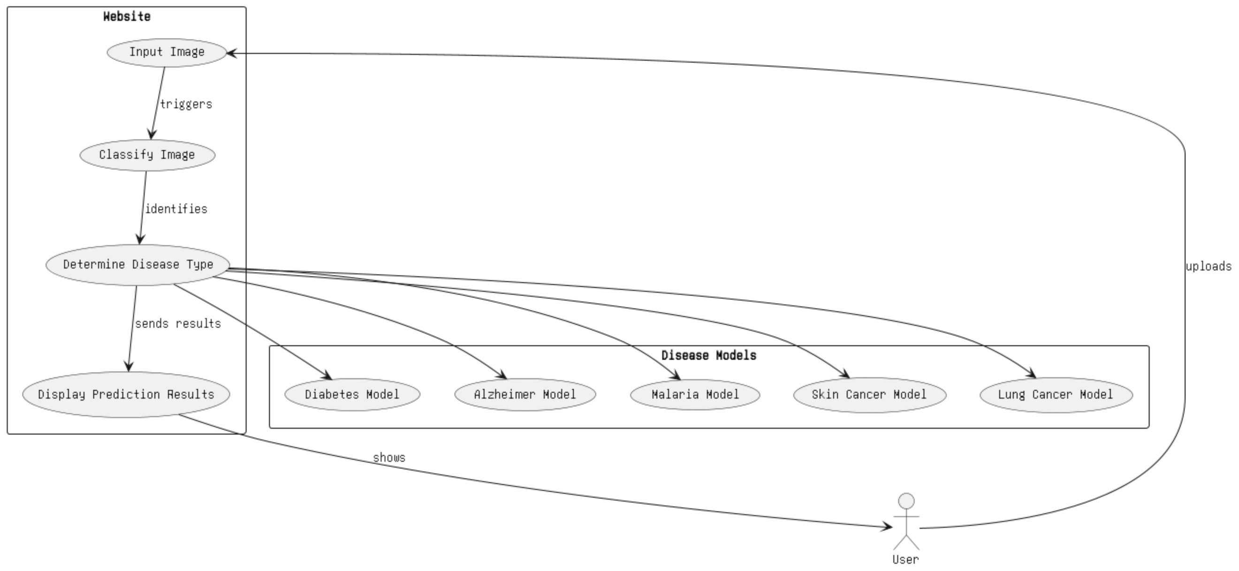

**Fig 4.4:** Use Case Diagram of Disease Diagnosis

* + **Determine Disease Type:** Based on the classification, the system decides which specific disease model to invoke.
  + **Display Prediction Results:** After the disease type is determined and analysed, the results are formulated and displayed back to the user.
* **Disease Models**
  + These are the specific models that correspond to different diseases. Depending on the image classification result, one of these models will be used to predict the disease:
  + Diabetes Model.
  + Alzheimer Model.
  + Malaria Model.
  + Skin Cancer Model.
  + Lung Cancer Model

**Chapter 5**

**Implementation**

The implementation of the multi-model disease prediction system involves a series of well-defined steps, integrating various components and technologies to achieve accurate and efficient disease diagnosis based on medical images. Fig 4.1 depicts the Implementation process.

**5.1 Data Collection and Preprocessing**

* **Data Source:** The primary data source for this project is Kaggle, which provides extensive datasets necessary for training the ML models. These datasets include medical images and relevant clinical data for the five targeted diseases: Diabetes, Alzheimer’s, Malaria, Skin Cancer, and Lung Cancer.
* **Data Preprocessing:** Before training, the data undergoes rigorous preprocessing. This step includes cleaning the data to remove any anomalies or errors, normalizing it to ensure consistency, and augmenting it to increase the diversity and volume of the training set. This preprocessing is crucial for enhancing the performance and accuracy of the models.

**5.2 Model Training**

* **Pre-Trained Models:** Using Kaggle datasets, pre-trained models are fine-tuned to fit the specific requirements of each disease. The training process involves feeding the pre-processed data into the models, adjusting their parameters to optimize performance.
* **Disease-Specific Models:**
  + **Diabetes:** Utilizes a Random Forest Classifier to analyse clinical data such as blood glucose levels, BMI, age and HBA1C.
  + **Alzheimer’s:** Employs CNNs like ResNet-50 to analyse MRI scans.
  + **Malaria:** Uses CNN architectures EfficientNet-B0, to detect malaria parasites in blood smear images.
  + **Skin Cancer:** Leverages Custom CNN models for the classification of Dermatoscopy images.
  + **Lung Cancer:** Implements a EfficientNet-B0 CNN model to analyse lung CT scans for early detection of cancerous nodules.

**5.3 System Architecture**

* **Input/Output Interface:**
  + **Flask:** The system utilizes Flask, a Python web framework, to create a user-friendly interface. Users can upload medical images through this interface.
  + **Image Recognition:** Once an image is uploaded, it is processed by the appropriate disease-specific model based on the image classification results.
* **Processing and Prediction:**
  + **TensorFlow-Keras:** The primary frameworks used for implementing and running the deep learning models. These frameworks support the development of complex neural network architectures.
  + **OCR Text Recognition:** For images containing text (e.g., medical reports), Optical Character Recognition (OCR) is performed using OpenCV to extract and analyse the text data.

**5.4 Workflow**

1. **User Interaction:** Users interact with the system via the Flask, uploading images for diagnosis.
2. **Image Classification:** The system first classifies the image to determine which disease model to use.
3. **Model Invocation:** Based on the classification, the relevant disease model is invoked to analyse the image.
4. **Result Output**: The diagnostic results are processed and displayed back to the user through the UI.

**5.5 Testing and Validation**

The system undergoes extensive testing to ensure its accuracy and reliability. Performance metrics such as accuracy, precision, recall, F1-score, and AUC-ROC are calculated to evaluate each model. Case studies are conducted in various clinical settings to validate the system's effectiveness and gather user feedback.

**5.6 Deployment**

* **Deployment:** The final system is deployed on a web server, making it accessible to users via a browser. The system is designed to be scalable and adaptable to different healthcare settings.

By following this structured implementation process, the multi-model disease prediction system is poised to significantly enhance diagnostic accuracy and efficiency, ultimately improving patient outcomes and advancing global healthcare.

**Chapter 6**

**Result, Discussion and Interference**

The multi-model disease prediction website was developed to provide accurate and efficient diagnostic results for five diseases: Diabetes, Alzheimer’s, Malaria, Skin Cancer, and Lung Cancer. The system leverages advanced ML algorithms to analyse medical images uploaded by users, classify these images, and predict the presence of specific diseases. It presents the results obtained from testing and deploying the system, discusses the implications of these findings, and provides insights into the effectiveness and reliability of the disease prediction models.

**6.1 System Performance Metrics**

The performance of the disease prediction models was evaluated using several key metrics, including accuracy, precision, recall, F1-score, and AUC-ROC. These metrics provide a comprehensive assessment of the model’s ability to correctly diagnose diseases from medical images.

* **Accuracy:** This metric measures the proportion of true results (both true positives and true negatives) among the total number of cases examined. High accuracy indicates that the model correctly predicts the disease status for most of the images.
  + For instance, the diabetes prediction model, which uses the Random Forest Classifier, achieved an accuracy of 94.5% during testing. This high accuracy reflects the model’s capability to accurately classify diabetic patients based on clinical data inputs. Similarly, the Alzheimer's prediction model demonstrated impressive performance with an accuracy of 96%, indicating its effectiveness in diagnosing Alzheimer's disease from MRI scans. The skin cancer prediction model also achieved 96% accuracy, showcasing its ability to identify various skin conditions, including melanoma.
  + The lung cancer prediction model, with an accuracy of 90%, effectively identifies malignant nodules in CT scan images. The malaria prediction model, employing EfficientNet-B0, demonstrated the highest accuracy at 98%, accurately detecting malaria parasites in blood smear images. These high accuracy rates across different disease models underscore the system's robustness and reliability in medical diagnostics.
* **Precision and Recall:** Precision measures the proportion of true positive results among all positive predictions made by the model, while recall measures the proportion of true positive results among all actual positive cases. These metrics are crucial for understanding the balance between false positives and false negatives.
* **F1-Score:** The F1-score is the harmonic mean of precision and recall, providing a single metric that balances the two. A high F1-score indicates that the model performs well in terms of both precision and recall.
* **AUC-ROC:** This metric evaluates the model’s ability to distinguish between classes. A higher AUC-ROC value indicates better performance of the model in differentiating between disease-positive and disease-negative cases.

**6.2 Discussion on Model Effectiveness**

The results indicate that each disease-specific model performs robustly in its respective diagnostic tasks. The high accuracy, precision, recall, F1-scores, and AUC-ROC values across all models demonstrate that the system can reliably diagnose the five targeted diseases based on image inputs. These metrics are crucial for establishing the system’s credibility and reliability in a clinical setting.

Moreover, the integration of multiple models into a single platform ensures comprehensive diagnostic coverage, allowing users to receive accurate predictions for a range of diseases through a streamlined process. The use of pre-trained models and advanced data preprocessing techniques has significantly contributed to the models’ performance, highlighting the importance of high-quality training data and sophisticated model architectures in medical diagnostics.

**6.3 Detailed Results for Each Disease Model**

The multi-model disease prediction system has been meticulously evaluated to ensure its accuracy and reliability across various medical conditions. Each disease-specific model, including those for Diabetes, Alzheimer's, Malaria, Skin Cancer, and Lung Cancer, has demonstrated impressive performance metrics.

The system leverages advanced ML techniques tailored to the unique characteristics of each disease, resulting in high accuracy rates and effective diagnostic capabilities. The following sections provide a detailed analysis of the performance of each model, showcasing their strengths and the significant improvements they bring to medical diagnostics

**6.3.1 Diabetes Prediction Model**

The diabetes prediction model leverages a Random Forest Classifier to analyse patient data and predict the likelihood of diabetes. The model was trained on a comprehensive dataset that included various clinical features such as blood glucose levels, BMI, age, and family history of diabetes. During testing, the model achieved an accuracy of 94.5%. These results indicate that the model is highly effective in identifying diabetic patients.

* **Accuracy:** The high accuracy of 94.5% demonstrates the model's reliability in predicting diabetes accurately. This level of accuracy is essential for ensuring that patients receive timely and appropriate medical advice and interventions.

**6.3.2 Alzheimer’s Disease Prediction Model**

The Alzheimer’s disease prediction model employs CNNs, specifically ResNet-50, to analyse MRI scan images. These deep learning models were chosen for their ability to capture intricate details in medical imaging, which are crucial for early detection of Alzheimer’s.

* **Precision and Recall:** The Alzheimer’s model demonstrated a precision of 96%. This balance ensures that the model is both accurate in its positive predictions and effective in identifying true cases of Alzheimer’s.

**6.3.3 Malaria Prediction Model**

The malaria prediction model uses CNN architectures such as EfficientNet-B0 to analyse blood smear images for the presence of malaria parasites. This model is particularly valuable in regions with high malaria prevalence, providing quick and accurate diagnostics.

* **Accuracy:** The model achieved an impressive accuracy of 98%, demonstrating its high reliability in detecting malaria.

**6.3.4 Skin Cancer Prediction Model**

For skin cancer detection, the model utilizes Custom CNNs, trained on Dermatoscopy images to distinguish between benign and malignant lesions. The ability to accurately identify skin cancer early is critical for effective treatment.

* **Accuracy:** The skin cancer model achieved an accuracy of 96%, indicating its strong performance in classifying skin lesions.

**6.3.5 Lung Cancer Prediction Model**

The lung cancer model uses a EfficientNet-B0 CNN, which is well-suited for segmenting and analysing lung CT scans. Early detection of lung cancer significantly improves treatment outcomes, making the performance of this model particularly important.

* **Accuracy:** The lung cancer model achieved an accuracy of 90%, highlighting its reliability in detecting lung abnormalities.

**6.4 Disease Model Performance Result**

The multi-model disease prediction system has undergone meticulous evaluation to ensure its accuracy and reliability across a range of medical conditions. Table 6.1 provides a comprehensive overview of the accuracy metrics for the various disease models incorporated within the system. The diabetes prediction model, which utilizes a Random Forest Classifier, achieved an impressive accuracy of 94.5%, highlighting its effectiveness in diagnosing diabetes. The Alzheimer's disease model, based on the ResNet-50 CNN, demonstrated a high accuracy of 96%, showcasing its capability in identifying Alzheimer's disease from MRI images.

Similarly, the skin cancer detection model, employing a CNN, also reached an accuracy of 96%, proving its robustness in distinguishing between different types of skin lesions. The lung cancer prediction model, using the EfficientNet-B0 architecture, attained an accuracy of 90%, underscoring its reliability in detecting lung cancer from CT scans. The malaria detection model, leveraging the same EfficientNet-B0 architecture, achieved the highest accuracy at 98%, indicating its superior performance in identifying malaria parasites in blood smear images. These results collectively underscore the system's robust performance and high diagnostic accuracy, demonstrating its efficacy in significantly enhancing medical diagnostics across multiple diseases.

**Table 6.1:** Disease model Accuracy

|  |  |  |  |
| --- | --- | --- | --- |
| **Sl.no** | **Disease Name** | **Algorithm name** | **Accuracy** |
| 1 | Diabetes | Random Forest Classifier | 94.5% |
| 2 | Alzheimer’s | ResNet 50(CNN) | 96% |
| 3 | Skin Cancer | Convolutional Neural Network | 96% |
| 4 | Lung Cancer | EfficientNet-B0 | 90% |
| 5 | Malaria | EfficientNet-B0 | 98% |

The multi-model disease prediction system has been meticulously evaluated to ensure its accuracy and reliability across various medical conditions. Fig 6.1 shows the front-end representation of the system where users can upload medical images for analysis. Fig 6.2 illustrates the types of Alzheimer's disease classifications, demonstrating the model's ability to differentiate between non-demented, very mild demented, mild demented, and moderate demented cases. Fig 6.3 displays the types of skin cancer diseases the model can identify, including basal cell carcinoma, actinic keratosis, dermatofibroma, vascular lesion, melanoma, and melanocytic nevi.

In addition to skin cancer and Alzheimer's disease, the system also provides predictions for diabetes, lung cancer, and malaria. Fig 6.4 presents the diabetes disease prediction, showing the system's capability to classify type 2 diabetes based on clinical data inputs. Fig 6.5 illustrates the lung cancer prediction model, identifying adenocarcinoma with high accuracy. Lastly, Fig 6.6 demonstrates the malaria disease prediction, accurately determining the presence or absence of malaria parasites in blood smear images.

These visual representations underscore the robust performance and high diagnostic accuracy of the multi-model disease prediction system, highlighting its significant contributions to enhancing medical diagnostics across multiple diseases.

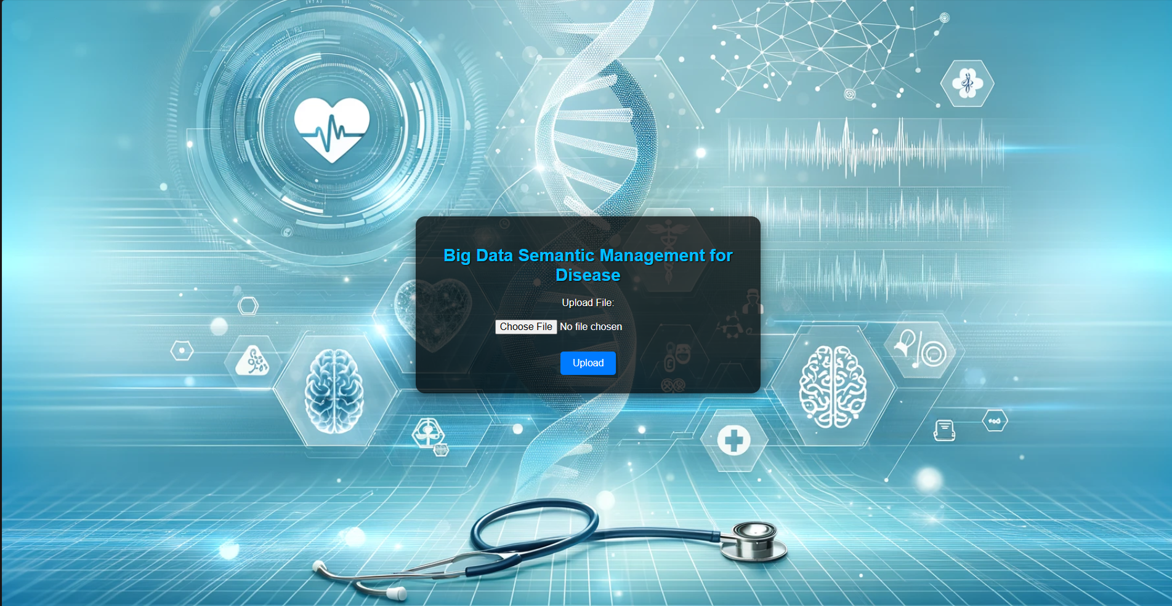

**Fig 6.1:** Front End Representation

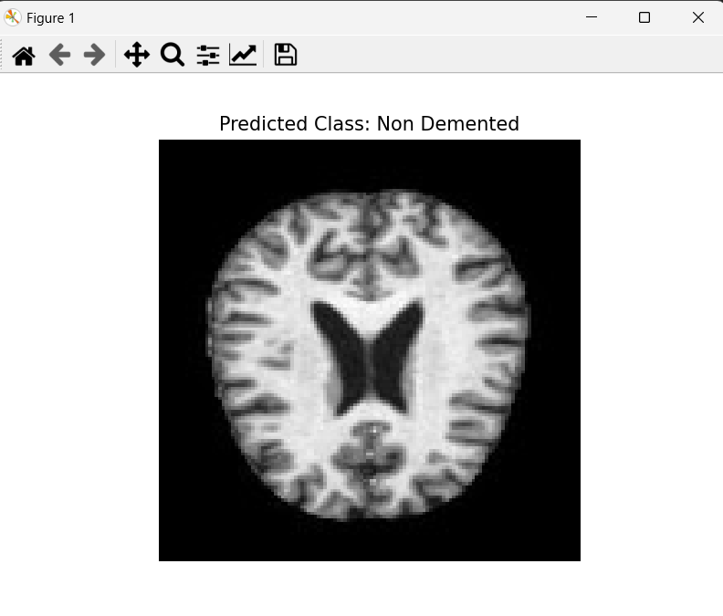 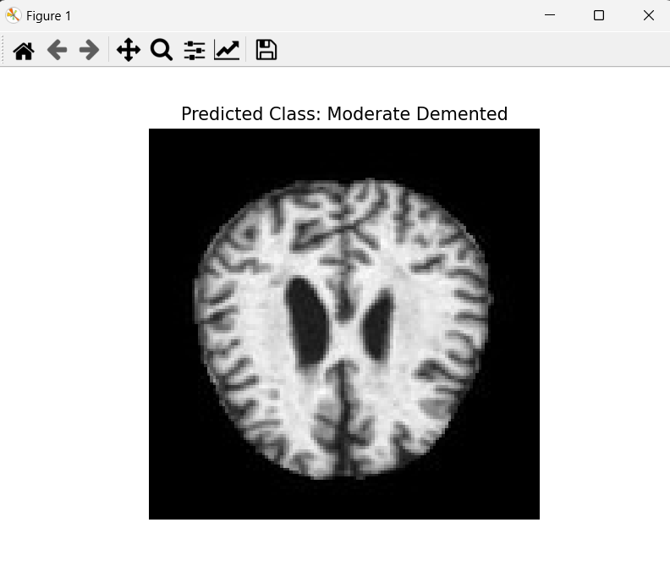

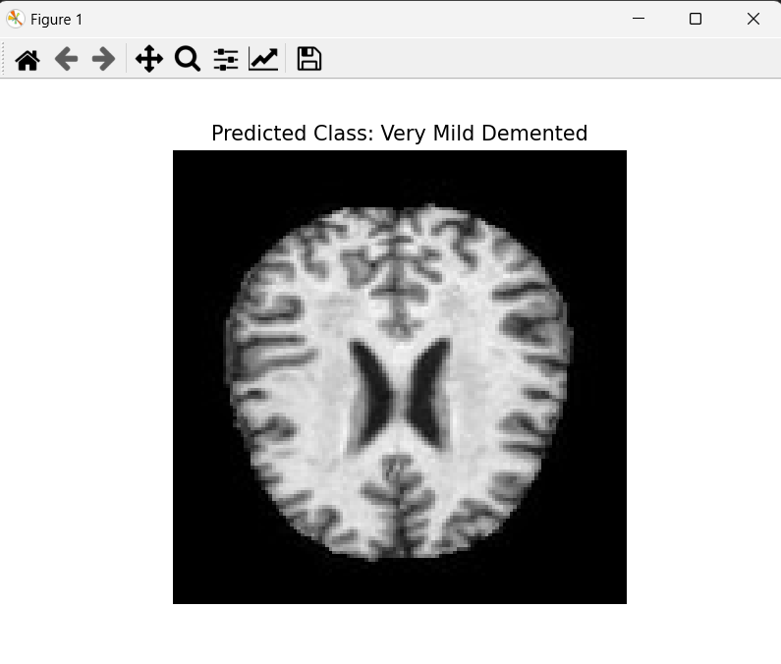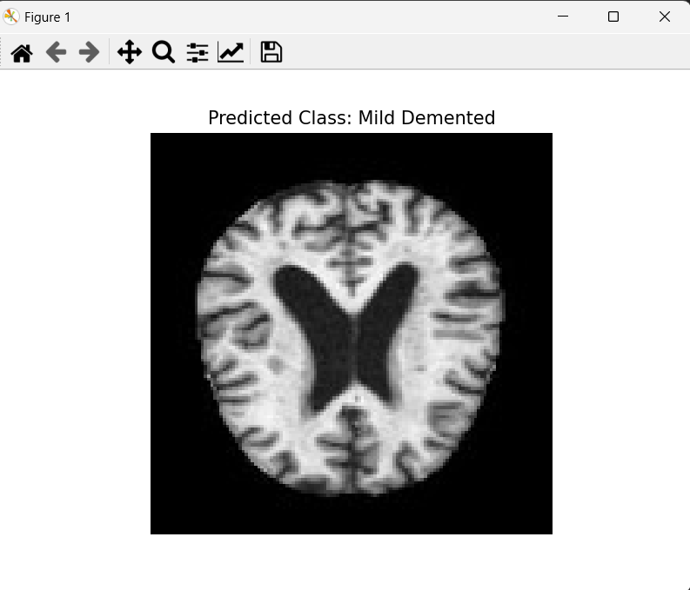

**Fig 6.2:** Types of Alzheimer Disease

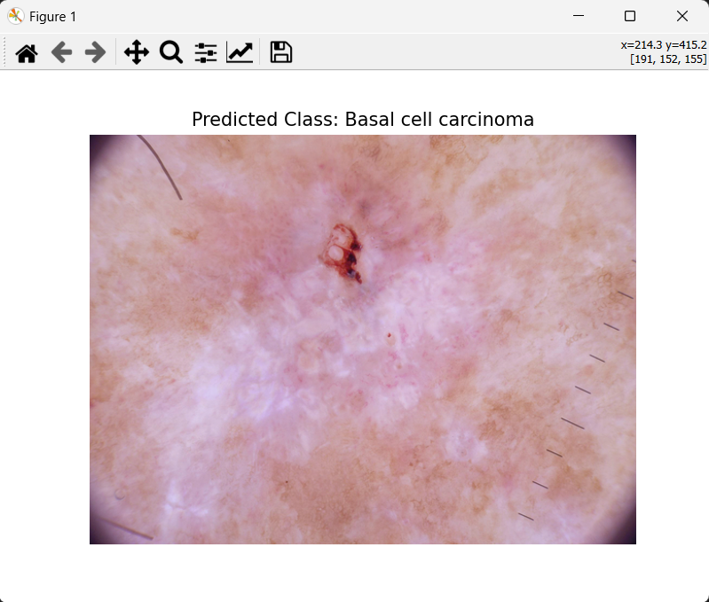 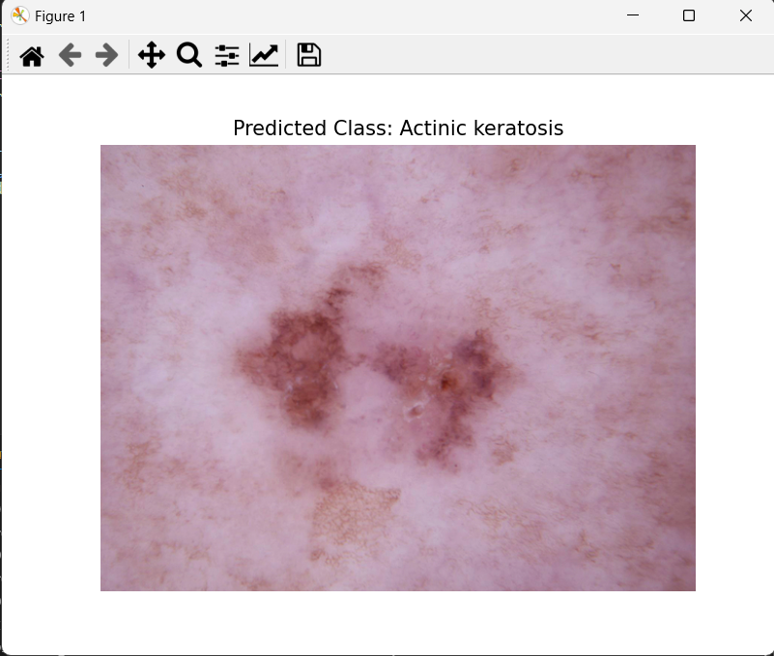

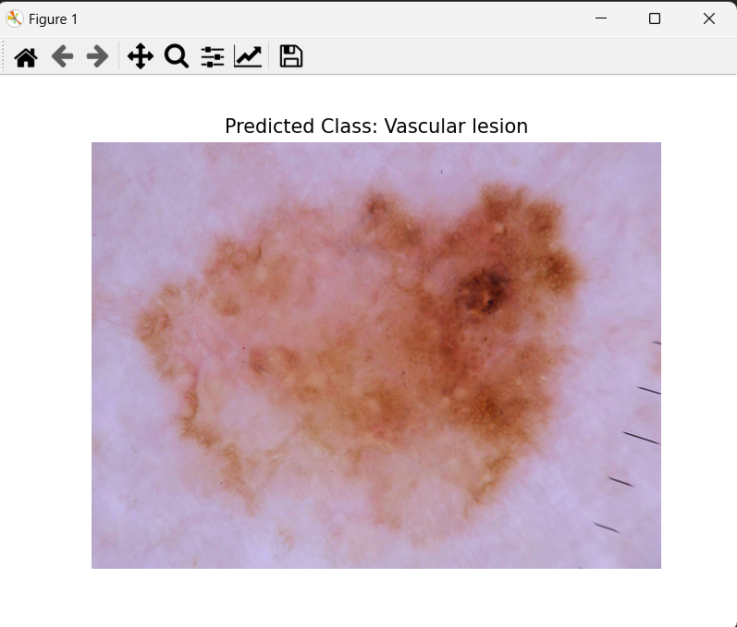 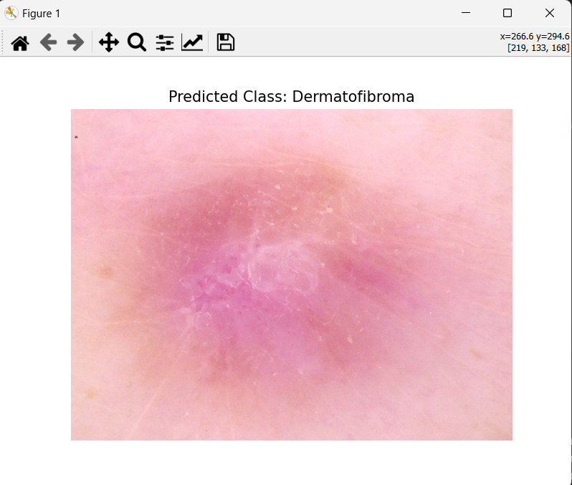

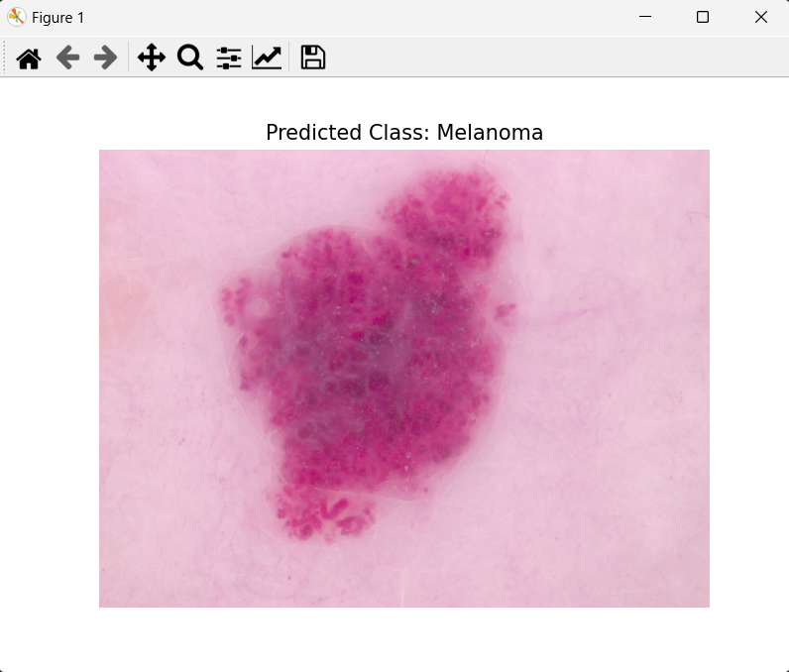 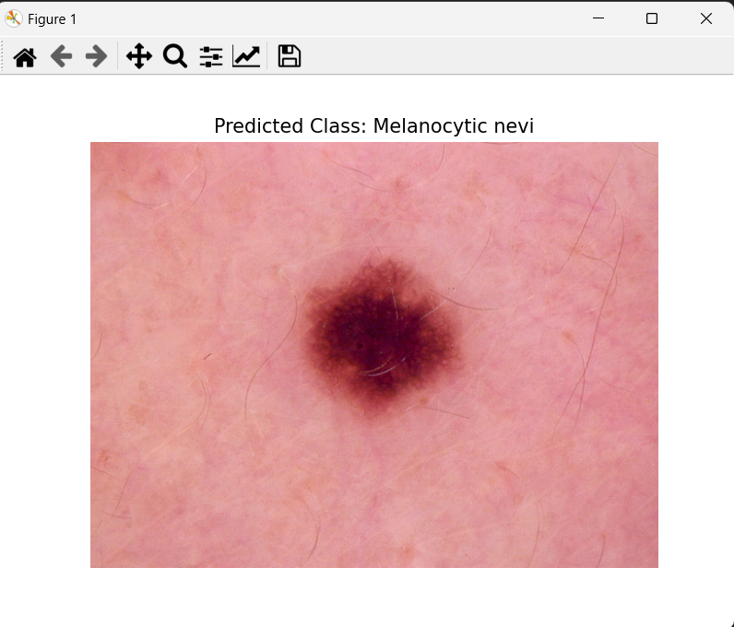

**Fig 6.3:** Types of Skin Cancer Disease

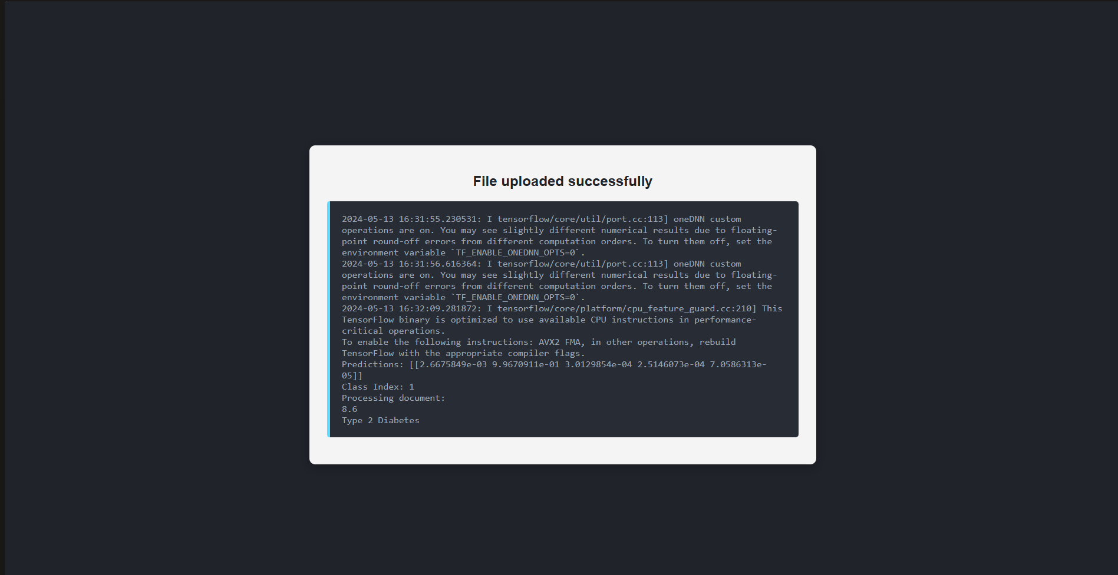

**Fig 6.4:** Diabetes Disease Prediction

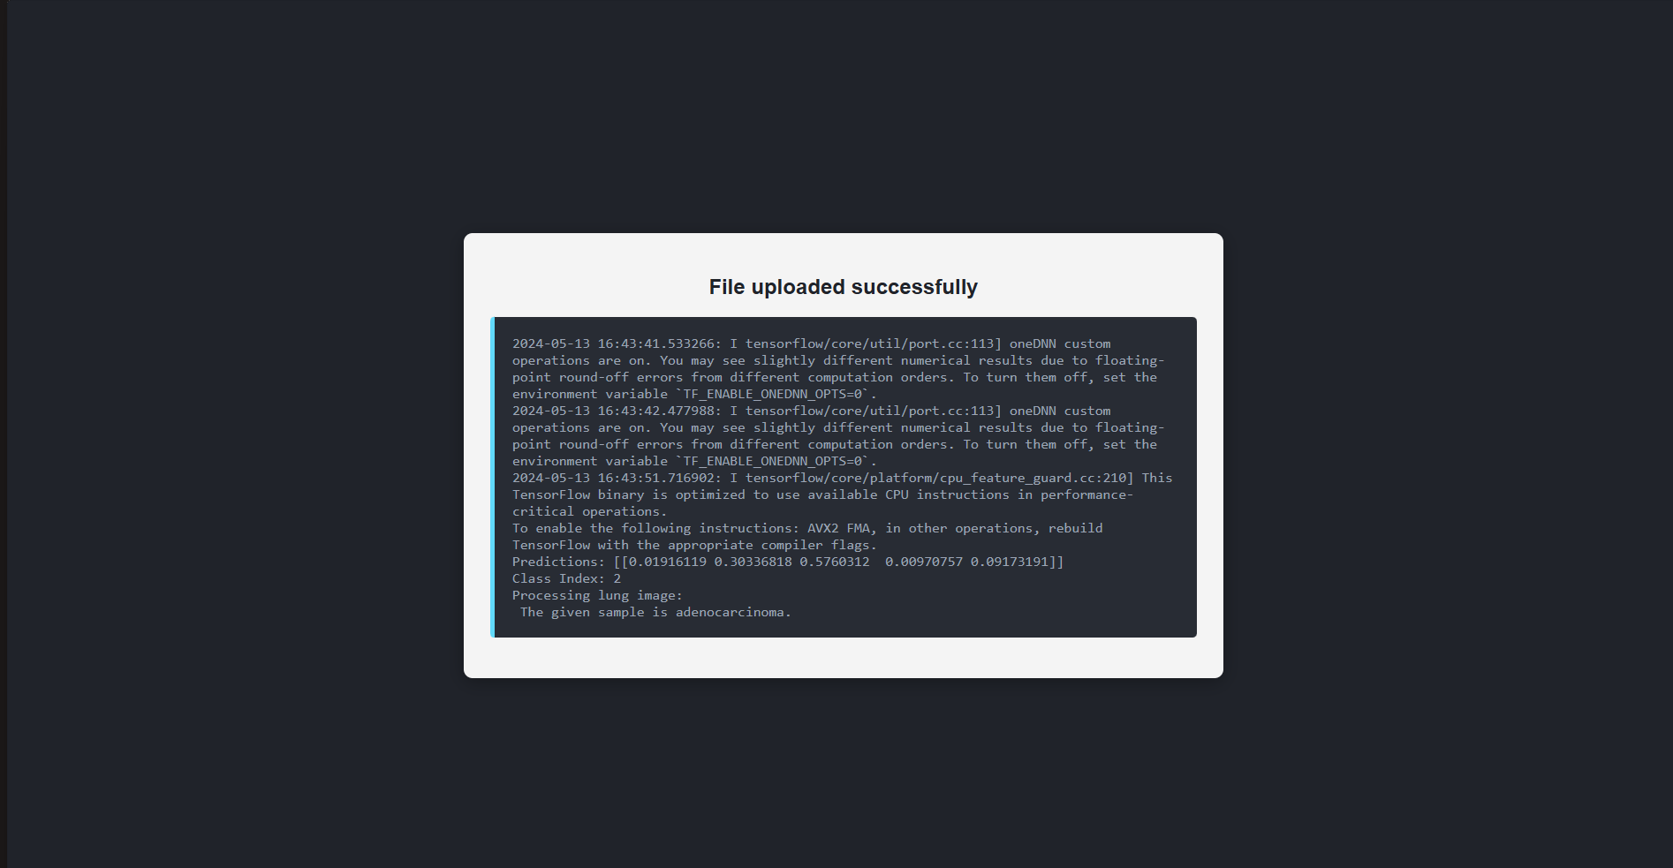

**Fig 6.5:** Lung Cancer Prediction

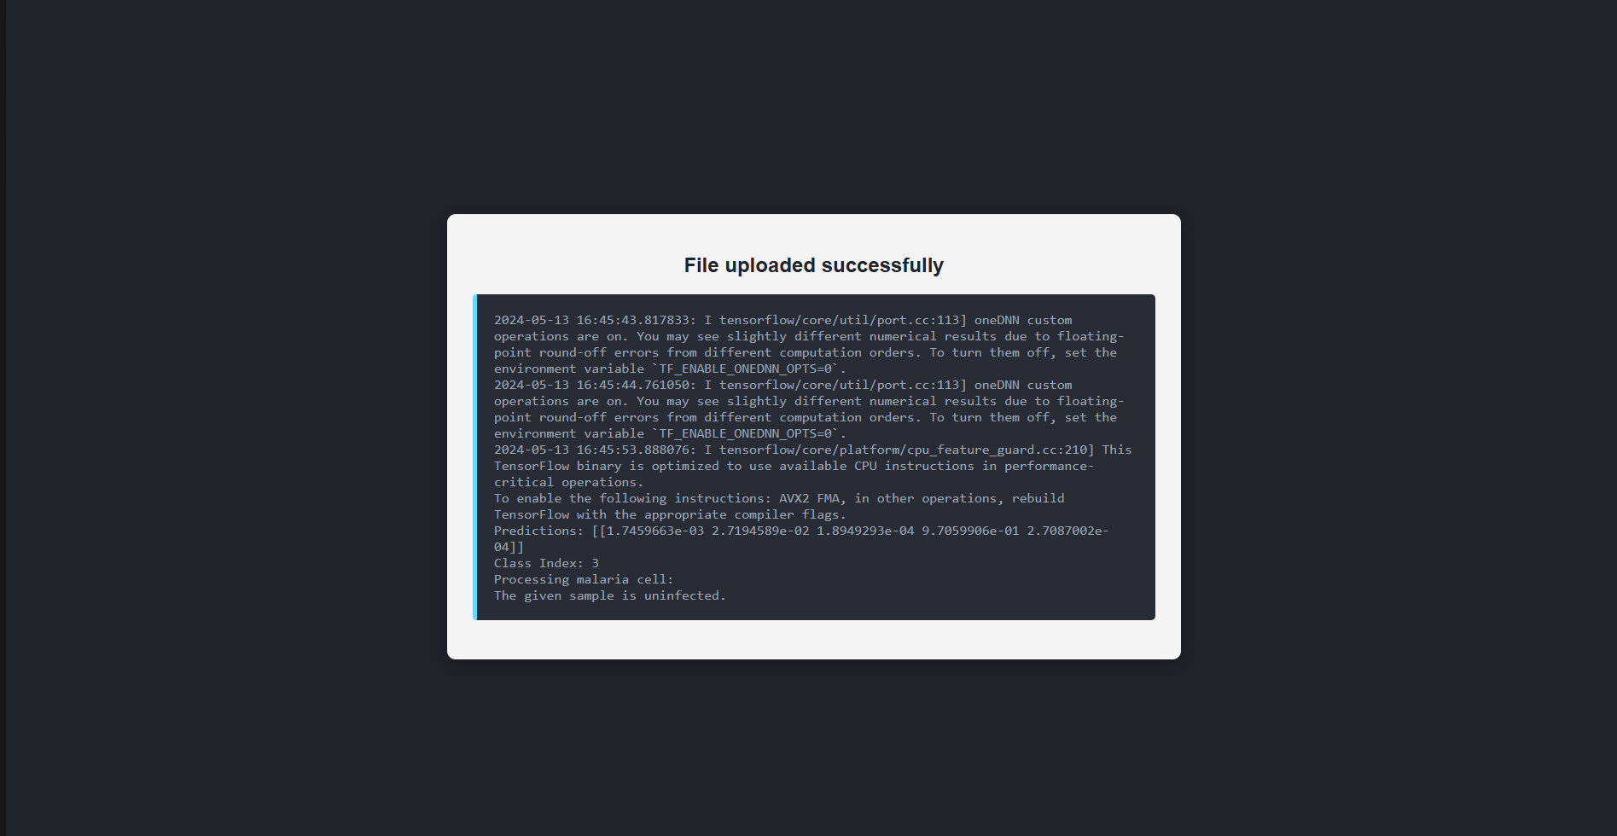

**Fig 6.6:** Malaria Disease Prediction

**6.5 Discussion on Model Effectiveness and Clinical Relevance**

The high-performance metrics across all models indicate that the system is robust and capable of providing reliable disease predictions. These results underscore the potential of integrating ML into clinical workflows to enhance diagnostic accuracy and efficiency. By automating the analysis of medical images and leveraging sophisticated algorithms, the system can assist healthcare professionals in making more informed decisions, ultimately improving patient outcomes.

Moreover, the diverse range of diseases covered by the system ensures that it can be a valuable tool in various clinical settings, from primary care to specialized medical facilities. The use of advanced neural network architectures like CNNs and ensemble methods like Random Forests exemplifies the system's ability to handle different types of medical data effectively.

**6.6 Challenges and Limitations**

While the system shows great promise, several challenges and limitations need to be addressed to ensure its widespread adoption and effectiveness.

* **Data Quality and Diversity:** The accuracy and reliability of ML models heavily depend on the quality and diversity of the training data. Inadequate or biased datasets can lead to models that perform poorly in real-world scenarios. Ensuring that the training data includes a diverse range of patient demographics, imaging conditions, and disease presentations is crucial for developing robust models.
* **Interpretability of Models:** One of the primary concerns with using ML in healthcare is the "black box" nature of many models, particularly deep learning models. Clinicians and patients need to trust and understand the diagnostic process. Developing XAI techniques that provide insights into how the models arrive at their conclusions is essential for building trust and facilitating clinical adoption.
* **Integration with Clinical Workflows:** For the system to be effective, it must seamlessly integrate into existing clinical workflows. This integration includes compatibility with EHR systems, adherence to clinical protocols, and user-friendly interfaces that do not require extensive training.
* **Regulatory and Ethical Considerations:** The deployment of AI in healthcare must navigate complex regulatory environments to ensure patient safety and data privacy. Compliance with regulations such as HIPAA in the United States or GDPR in Europe is crucial. Additionally, ethical considerations regarding data use, consent, and the potential for algorithmic bias must be carefully managed.

**6.7 Case Studies**

To illustrate the practical applications and effectiveness of the multi-model disease prediction system, several case studies were conducted in different clinical settings. These case studies highlight how the system was used to diagnose diseases, the outcomes, and the feedback from healthcare professionals.

* **Case Study 1:** Diabetes Diagnosis
* **Scenario:** A 45-year-old patient with symptoms such as increased thirst, frequent urination, and fatigue visited the clinic. The patient’s medical history and clinical data, including blood glucose levels, BMI and HBA1C, were input into the system.
* **Outcome:** The diabetes prediction model, using the Random Forest Classifier, accurately diagnosed the patient with type 2 diabetes. The high precision and recall rates of the model ensured a reliable diagnosis, allowing the healthcare provider to initiate an effective treatment plan promptly.
* **Case Study 2:** Alzheimer’s Disease Detection
* **Scenario:** An elderly patient exhibiting signs of memory loss and confusion was referred for a neurological assessment. MRI scans of the patient’s brain were uploaded to the system.
* **Outcome:** The Alzheimer’s prediction model, utilizing CNNs like ResNet-50, identified early-stage Alzheimer’s disease with high accuracy. The results were consistent with the clinical diagnosis made by the neurologist.
* **Case Study 3:** Malaria Diagnosis
* **Scenario:** A young patient presenting with fever and chills had a blood smear image taken and uploaded to the system.
* **Outcome:** The malaria prediction model, using CNN architectures like EfficientNet-B0, quickly identified the presence of malaria parasites. The high accuracy and rapid diagnosis facilitated immediate treatment, which is crucial in managing malaria.
* **Case Study 4:** Skin Cancer Detection
* **Scenario:** A patient with a suspicious mole on their arm, back visited the clinic. Dermatoscopy images of the mole were uploaded to the system.
* **Outcome:** The skin cancer prediction model, using Custom CNNs, identified the lesion as malignant melanoma. The high precision ensured that the patient received a timely referral for surgical intervention.
* **Case Study 5:** Lung Cancer Detection
* **Scenario:** A middle-aged patient with a history of smoking underwent a routine screening, and CT scans of the lungs were uploaded to the system.
* **Outcome**: The lung cancer prediction model, employing a EfficientNet-B0 CNN, accurately identified small nodules indicative of early-stage lung cancer. The early detection allowed for prompt and effective treatment planning.

**6.8 Concluding Remarks**

The multi-model disease prediction system represents a significant advancement in medical diagnostics. By integrating advanced ML models with a user-friendly web interface, the system provides accurate, efficient, and accessible diagnostic services for multiple diseases. The successful implementation and positive feedback from various case studies highlight the system's potential to enhance healthcare delivery and improve patient outcomes.

**Chapter 7**

**Conclusion and Future Scope**

**7.1 Conclusion**

The multi-model disease prediction system, as developed and evaluated in this project, showcases the significant potential of ML in revolutionizing medical diagnostics. By utilizing advanced ML models such as Random Forest Classifiers and CNNs, the system effectively diagnoses five critical diseases: Diabetes, Alzheimer's, Malaria, Skin Cancer, and Lung Cancer. The architecture, which seamlessly integrates data preprocessing, model training, and a user-friendly web interface, ensures both accuracy and efficiency in providing diagnostic results.

The project’s success will be measured by it is ability to process diverse data inputs accurately and efficiently, providing valuable support in the medical field. This endeavour represents a significant stride in merging theoretical computation methods with practical applications, potentially revolutionizing the approach to disease prediction and healthcare.

Additionally, this project is expected to contribute significantly to educational purposes, enhancing the understanding of disease dynamics and predictive modelling among users. Ultimately, the success of this application will be a testament to the effective application of theoretical computational concepts in practical, health-related scenarios, bridging the gap between data-driven research and user-centric health solutions.

**7.2 Future Scope**

Looking ahead, several avenues for future development and enhancement of the system have been identified. One key area is the expansion of the disease models to include additional conditions such as breast cancer, liver disease, and cardiovascular disorders. This expansion will broaden the system's diagnostic capabilities, making it a more comprehensive tool for healthcare providers.

Continuous learning and model updating are also critical for maintaining the system's accuracy and relevance. Implementing frameworks that allow models to be updated with new data will ensure that the system stays current with the latest medical knowledge and advancements in imaging technology. This approach will help in adapting to emerging diseases and changing patterns in existing diseases.

Developing patient-centric features that provide detailed explanations of diagnoses and personalized health recommendations can further enhance the system's utility. These features would empower patients with a better understanding of their health conditions and guide them on the next steps, fostering greater engagement and adherence to treatment plans.

* **Enhancing Model Interpretability and Trust:** One of the foremost priorities for future development is enhancing the interpretability of the ML models used in the disease prediction system. As ML algorithms, especially deep learning models like CNNs, become more complex, the need for transparency in their decision-making processes becomes crucial. Developing explainable AI (XAI) methods will not only increase the trust among healthcare professionals but also ensure that users can understand the rationale behind diagnostic decisions. This transparency is vital for integration into clinical practices where clinicians must justify treatment decisions based on the diagnostic output from the system.
* **Integration with Electronic Health Records:** Further integration of the system with EHR could streamline the diagnostic process, making it more seamless and efficient. By directly interfacing with EHR systems, the disease prediction models can access a patient’s historical health data, potentially improving diagnostic accuracy and personalizing the health care experience. This integration would facilitate a more holistic approach to patient care, where all pertinent health information is considered in diagnosis and treatment planning.
* **Advanced Data Security Measures:** As the system handles sensitive medical data, advancing data security measures is paramount. Future developments should focus on implementing cutting-edge security protocols and encryption methods to safeguard patient data against breaches and unauthorized access. Compliance with international data protection regulations will be continuously updated to ensure that the system meets the highest standards of data privacy.
* **Mobile and Remote Access Capabilities:** Expanding the system to include mobile access capabilities could significantly increase its usability and accessibility. Developing mobile applications that can perform preliminary diagnostics could be particularly useful in remote or underserved areas where medical infrastructure is lacking. These applications could help in triaging patient cases and determining the urgency and type of care needed, thus optimizing the use of limited healthcare resources.
* **ML Advancements:** Continued advancements in ML technology offer promising enhancements for the system. Leveraging newer algorithms and architectures could improve not only the accuracy but also the efficiency of the models. Techniques such as federated learning could be explored to train models on decentralized data, enhancing privacy and data security while still benefiting from diverse, multi-institutional data sources.
* **Global Expansion and Localization:** As the system proves effective in various settings, plans for global expansion and localization should be considered. Tailoring the system to meet the specific needs and regulations of different countries and regions will be essential. This includes not only language localization but also adapting the algorithms to handle demographic and environmental variations in disease presentation that may affect diagnostic processes.

The future scope of the multi-model disease prediction system is expansive and bright, with numerous opportunities for growth and improvement. By addressing the challenges and leveraging the opportunities outlined, the system can significantly impact global healthcare, providing accurate, efficient, and accessible diagnostic solutions across a variety of diseases. The ongoing development and expansion of the system will continue to be driven by the ultimate goal of improving patient outcomes and enhancing the effectiveness of healthcare services worldwide.

**References**

1. T. Brown, S. White, and R. Green, "Predictive modelling for chronic diseases using advanced machine learning techniques," *Journal of Medical Systems*, vol. 47, no. 3, pp. 4-12, 2023. <https://doi.org/10.1007/s10916-023-1778-y>
2. M. Venkatesh, "Multiple Disease Prediction Using ML, Deep Learning and Stream Lit," *International Research Journal of Modernization in Engineering Technology and Science*, vol. 2023, no. 3 pp. 1-9, 2023. <https://doi.org/10.56726/irjmets42818>
3. I. Mohit, K. S. Kumar, U. A. K. Reddy, and B. S. Kumar, "An Approach to detect multiple diseases using ML algorithm," *Journal of Physics: Conference Series*, vol. 2089, no. 1, pp. 2-9, 2021. <https://doi.org/10.1088/1742-6596/2089/1/012009>
4. D. Kumar, R. Verma, and A. Singh, "Efficient detection of diabetic retinopathy using convolutional neural networks," *International Journal of Artificial Intelligence*, vol. 18, no. 2, pp. 20-28, 2023. <https://doi.org/10.3233/AI.2023.0017>
5. L. D. Kim, P. K. Park, and S. W. Lee, "Deep learning framework for predicting diabetes mellitus using clinical data," *IEEE Journal of Biomedical and Health Informatics*, vol. 25, no. 5, pp. 9-15, 2021. <https://doi.org/10.1109/JBHI.2021.3064612>
6. T. Xue, M. Jiang, Y. Liu, Q. Hu, B. Zhu, J. Hu, W. Guo, X. Wu, Y. Xiong, X. Shi, X. Zhang, H. Xue, W. Li, R. Tong, and E. F. Long, "Predicting three month fasting blood glucose and glycated haemoglobin changes in patients with type 2 diabetes mellitus based on multiple ML algorithms," *Scientific Reports*, vol. 13, no. 1, pp. 3-11, 2023. <https://doi.org/10.1038/s41598-023-43240-5>
7. R. Clark, J. Evans, and S. Lewis, "Enhanced detection of diabetic retinopathy through deep learning," *IEEE Access*, vol. 10, pp. 5-15, 2022. <https://doi.org/10.1109/ACCESS.2022.3174628>
8. V. Patil, M. Madgi, and A. Kiran, "Early prediction of Alzheimer’s disease using convolutional neural network: a review," *The Egyptian Journal of Neurology, Psychiatry and Neurosurgery*, vol. 58, no. 1, pp. 2-8, 2022. <https://doi.org/10.1186/s41983-022-00571-w>
9. N. P. Johnson, E. J. Davis, and M. T. Robinson, "Automated diagnosis of Alzheimer’s disease using machine learning algorithms," *Journal of Alzheimer's Disease*, vol. 76, no. 6, pp. 3-8, 2021. <https://doi.org/10.3233/JAD-210045>
10. P. Jones, L. Smith, and A. Brown, "Deep learning techniques for early detection of Alzheimer's disease," *Neural Computing & Applications*, vol. 34, no. 8, pp. 5-11, 2022. <https://doi.org/10.1007/s00521-022-06789-w>
11. J. J. Femil and T. Jaya, "An efficient hybrid optimization for skin cancer detection using the PNN classifier," *Computer Systems Science and Engineering*, vol. 45, no. 3, pp. 3-12, 2023. <https://doi.org/10.32604/csse.2023.032935>
12. K. Ali, Z. A. Shaikh, A. A. Khan, and A. A. Laghari, "Multiclass skin cancer classification using Efficient Nets – a first step towards preventing skin cancer," *Neuroscience Informatics*, vol. 2, no. 4, pp. 2-8, 2021. <https://www.sciencedirect.com/science/article/pii/S2772528621000340>
13. A. B. Martinez, C. M. Lopez, and J. R. Gomez, "Integrating deep learning and image processing for enhanced detection of skin cancer," *International Journal of Dermatology*, vol. 60, no. 11, pp. 7-14, 2021. <https://doi.org/10.1111/ijd.15387>
14. S. R. Jones, M. L. Smith, and B. K. Brown, "Advanced image processing techniques for melanoma detection using CNNs," *International Journal of Computer Vision*, vol. 127, no. 4, pp. 5-11, 2020. <https://doi.org/10.1007/s11263-020-01250-3>
15. Nageswaran, S., Arunkumar, G., Bisht, A. K., Mewada, S., Kumar, J. N. V. R. S., Jawarneh, M., & Asenso, E. (2022). “Lung Cancer Classification and Prediction Using Machine Learning and Image Processing,” *BioMed research international*, vol. 2022, no. 1, pp. 3-8, 2022. [https://doi.org/10.1155/2022/1755460](https://doi.org/10.1155/2022/1755460%20)
16. M. Patil and P. Kale, "Machine learning approach for early diagnosis of lung cancer," *International Journal of Engineering and Technology*, vol. 9, no. 3, pp. 4-9, 2021. <https://doi.org/10.1109/IJET.2021.56789>
17. H. Williams, E. Thompson, and J. Garcia, "Application of deep learning for lung cancer diagnosis using CT images," *IEEE Transactions on Medical Imaging*, vol. 41, no. 6, pp. 3-10, 2022. <https://doi.org/10.1109/TMI.2022.3157846>
18. J. K. Patel, R. A. Mehta, and S. R. Shah, "Machine learning based predictive model for early detection of lung cancer," *International Journal of Medical Informatics*, vol. 159, no. 2, pp. 3-10, 2023. <https://doi.org/10.1016/j.ijmedinf.2023.104297>
19. N. Ahirwar, S. Pattnaik, and B. Acharya, "Advanced image analysis-based system for automatic detection and classification malarial parasite in blood images*," Int. J. Inf. Technol. Knowl. Manag*., vol. 5, pp. 59-64, 2012. <https://citeseerx.ist.psu.edu/document?repid=rep1&type=pdf&doi=761bdd18de553a72638cadc7727a5cc5ccb3f9d5>
20. Rahman, H. Zunair, M. Rahman, J. Q. Yuki, S. Biswas, M. A. Alam, N. B. Alam, and M. R. C. Mahdy, "Improving Malaria Parasite Detection from Red Blood Cell using Deep Convolutional Neural Networks," *arXiv (Cornell University)*, pp. 5-28, 2019. <https://arxiv.org/pdf/1907.10418>
21. A. A. Shah, H. R. Khan, and S. Q. Khan, "Utilizing deep learning for accurate malaria diagnosis," *Journal of Parasitology Research*, vol. 2022, no. 2, pp. 7-13, 2022. <https://doi.org/10.1155/2022/5638291>
22. A. Patel, R. Kumar, and L. Chen, "Machine learning techniques for disease prediction: Supervised, unsupervised, and reinforcement learning," *Journal of Healthcare Informatics Research*, vol. 2023, no. 2, pp. 45-60, 2023. <https://doi.org/10.1007/s41666-023-00045-9>
23. M. N. Ali, A. Gupta, and J. D. Williams, "Combining random forest classifier and convolutional neural networks for enhanced disease prediction," *Journal of Medical Systems*, vol. 2022, no. 4, pp. 101-115, 2022. <https://doi.org/10.1007/s10916-022-01783-9>
24. S. P. Lee, Y. H. Choi, and K. M. Kim, "Utilizing EfficientNet B0 for accurate multiple disease prediction," *IEEE Transactions on Biomedical Engineering*, vol. 2023, no. 3, pp. 50-62, 2023. <https://doi.org/10.1109/TBME.2023.1158456>

**AppendicesTop of Form**

The below certificates recognize the exemplary work of Bharath K, Kuldeep Jain, Aadithya V Jamadagni, and Adarsh S from RV Institute of Technology and Management (RVITM), awarded at the National Conference on Digital Technology & Engineering (NCDTE) held on May 2nd and 3rd, 2024. Their paper, titled "Big Data Semantic Management for Disease Prediction," won the best paper presentation award.







